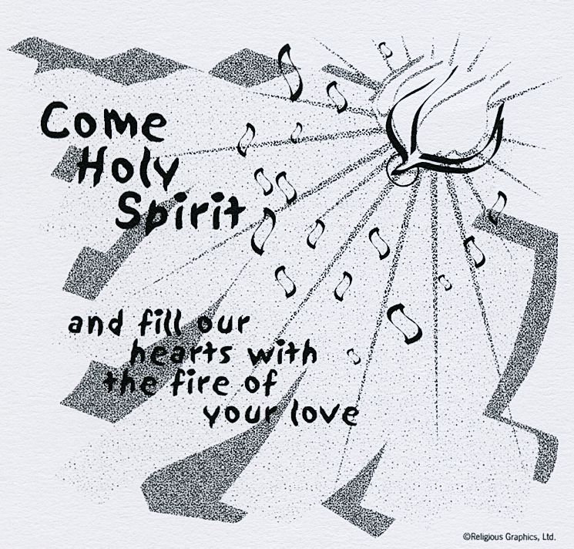
ST. ROSE CHURCH St. Rose, IIlinois
Fr. Edward F. Schaefer
18010 St. Rose Road
526-4118 Rectory

SUNDAY MASS 10:00AM
SAT. VIGIL MASS 4:00PM
WEEKDAY MASS 7:45AM
RECONCILIATION Saturday: 3:15 – 3:45PM
WEBPAGE: www.strosechurchil.com
EMAIL: belpsros@outlook.com
FACEBOOK: St. Rose Catholic Church – St. Rose, IL

MASS WILL BE LIVE STREAMED ON OUR FACEBOOK PAGE SATURDAYS AT 4PM

SUNDAY COLLECTIONS:
Seminarian Education: $125. Weekly Envelopes: $2,780.00
Ascension: $125.00 Sister Parish: $10.00 Capital Improvement Fund: $ 60.00

INTENTIONS: MASS
Mon 7:45AM Blessed Virgin Mary, Mother of the Church No Mass
Tue 7:45AM Weekday No Mass
Wed 7:45AM Visitation of the Blessed Virgin Mary No Mass
Thu 7:45AM St. Justin No Nass
Fri 7:45AM Sts. Marcellinus & Peter No Mass
Sat 4:00PM Vigil The Most Holy Trinity Terry Thomas
“ “ “ “ Bertha Wilke
“ “ “ “ Freemont & Rose Gnaedinger
Sun 10:00AM The Most Holy Trinity For the Parish

SERVERS: Sat 4PM Marissa Jansen, Everett Jansen, Gavin Schneider, Alaina Schrage
Sun 10AM Addison Thole, Aubrey Thole, Lukas Winkeler, William Timmermann
READERS: Sat 4PM Peggy Thole Sun 10AM Pam Andrews
EUCHARISTIC MINISTERS: Sat 4PM Deb Knebel Sun 10AM Rose Jansen
OFFERTORY: Sat 4PM Thomas, Wilke & Gnaedinger Families
Sun 10AM Dennis Schumacher, David Thole, Bill Timmermann

VOCATION CUP: The next family to receive the Vocation Cup is the Colby Voss Family.
NOTE FROM BISHOP MCGOVERN:
The one who does justice will live in the presence of the Lord – Psalm 15
On Memorial Day, let us take a moment to honor those who gave their lives for our country.
Our warmest wishes on Memorial Day, 2023 and deepest gratitude for the ultimate sacrifice
of our fallen heroes.

SYMPATHY:
Our sympathy to the family of Donald Hintz. Donald, who passed away recently, was the
step-father of Kenneth (Diane) Thole. May Donald enjoy the reward of eternal life.

HAVE YOU REMEMBERED ST. ROSE PARISH IN YOUR ESTATE PLANNING?

CONGRATULATIONS:
To Blake Benhoff and Lydia Rehkemper who were married here last weekend. Many blessings to them!
CONGRATULATIONS:
To Bentley Mark Williams and Rivie Marie Gross who were Baptized here last weekend.
Bentley, is the son of Anthony Williams (deceased) and Krissy (Connell) Williams.
Rivie is the daughter of Tyler and Erica (Maurer) Gross. Many blessings to them!
CONGRATULATIONS:
To Lacey Benhoff, Elyse Faust & Alyssa Gall who graduated SIUE 2023.
CONGRATULATONS 2023 GRADUATES:
Congrats to the following Central High School graduates: Dominic Boeing, Joseph Cirrincione,
Ty Kueper, Abigail Sturgeon, Clara Tebbe, Dane Thole and Keira Veizer and to the following
Mater Dei graduates: Brayden Buehne, Cora Meyer and Avery Rahden.
CONGRATULATIONS:
To Joe Cirrincione, Dominic Boeing and Gavin Winkeler who were among the Central High School
Ag Industrial Arts Winners and to Joe Cirrincione who received a Business & Technology Award.
CONGRATULATIONS:
To Keira Veizer and Clara Tebbe who received a Language Arts & Foreign Language Award from
Cental High School and to Julie Kueper, Keira Veizer and Clara Tebbe who received Family and
Consumer Science Awards.
CONGRATULATIONS:
To Abigail Sturgeon who graduated the Clinton County Creating Entrepreneurial Opportunities Program
Class of 2023.
CONGRATULATIONS:
To Carly Etter who was inducted into the Honor Society of Phi Kappa Phi at SIU Carbondale.
PARISH SCHOOL OF RELIGION:
PSR will be needing 3 new Religion Teachers (3rd grade, 5th grade and 6th grade) for the upcoming school year. If interested give Marilyn Bruggemann a call 618-210-1258.
HAPPY ANNIVERSARY:
May 31 Marvin & Beth Meier ’75 Jun 1 Mark & Betsy Buehne ‘84
Jun 01 Gervase & Dolores Henrichs ’60 Jun 2 Gary & Sherry Wiegmann ‘90
Jun 04 Francis & Agnes Huelsmann ’69
HAPPY BIRTHDAY:
May 29 John Detmer May 31 Judith Woltering May 1 Dan Boeing
May 29 Madeline Fuhler 15 Jun 01 Kyson Jacob 1 Jun 03 Renee Bange
May 29 Laura Lohman Jun 02 Kathleen Kohlbrecher Jun 03 Mason Eversgerd 5
May 30 Nancy Faust Jun 02 Katie Rehkemper Jun 03 Renee Richter
May 31 Amy Diekemper Jun 02 Phillip Schuette Jun 04 Asher Jansen 8
May 31 Jan Kalmer Jun 02 Nolan Schuette 5 Jun 04 William Timmermann
May 31 Richard Thole Jun 02 Lydia Schulte 6
VOCATIONS:
Pentecost!! What a celebration! The Lord sends us the Holy Spirit to guide us on our way after redeeming us from our sins. The Apostles were imbued with the Holy Spirit and began speaking in many tongues so everyone understood as in contrast to the story of the Tower of Babel. May we be blessed with the right words as we talk with our youth about the possibility of choosing a religious vocation – priest, sister, or a brother. Also this weekend, we gratefully and prayerfully remember all those who sacrificed their lives serving our country. This ultimate giving of oneself is the most selfless act of love we humans perform.
Have a Safe and Happy Memorial Day Weekend!

