St. Felicitas Church
PRAYER REQUEST

Please pray for those who need the Lord healing in body, mind or spirit, especially Florence Huelsmann, Margie McQuade, Taylor Marti, Gerald Hilmes, Ken Wellen,
Jim Jansen, Ed McQuade, Kathy Gress, Sr. Diane and all who asked for our prayers.

and all who asked for our prayers.
Fr. Dale Maxfield, and all who asked for our prayers.

13322 Church Road
Carlyle, IL 62231
Phone: 594-3040 Fax: 594-3040
stfelbp@wisperhome.com

Father Ed Schaefer
belpsros@outlook.com
Cell: 618-526-4118

Father Tom Killeen

Parish Pastoral Council: Justin Benhoff, Gene Bickl, Cindy Gnaedinger, Joe Luebbers
Finance Council: Mary Huelsmann, John Ketterer, Dan Potthast, Allen Thole and Margie McQuade.
Parish Trustees: Barry Hampel and Alan Heldorfer
Administrative Asst: Deb Rakers 618-698-9141 or 618-594-3040

Seventh Sunday in Ordinary Time
Love your enemies, Jesus tells us, challenging society’s values and even common sense. Why should we love those who have hurt us? Well, one of the greatest gifts we can give is our mercy. We may feel that our enemy doesn’t deserve our mercy, but it may help to realize that it is God’s mercy that we extend, that it’s God mercy that counts. Let us think of those who have wronged us and pray that we can be instruments of God’s mercy in their lives.
Before Jesus taught his disciples the importance of showing mercy, David put such a lesson into action when threatened by Saul. He and his comrade could have killed the king or taken him prisoner, but David ordered that his life be spared. Listening to today’s readings, let us listen for ways in which we can show mercy to those in need.

Question of the Week
Who has hurt me to whom I can give mercy? How can I go about giving mercy, giving life, to them?

WEEKLY OFFERING

02-13-22
Envelopes 29
Envelopes Total…….$.1220.00
Lose Collection………..$212.00
Grand Total………… $1432.00

Our monthly income for January 2022 was $5035.00 and our monthly expenses totaled $5914.00. Please give as you are able.
Thank you for your generosity!

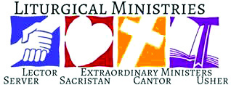

February 20: 9:30 a.m.
LECTOR: Alayna Benhoff
MINISTER OF HOLY COMMUNION: Cindy Gnaedinger
GIFT BEARERS: Justin & Pam Benhoff family
SERVERS: PSR class
USHERS: Dan Potthast and Dan Ketterer
MUSCIAN: Maribeth Detmer

February 27: 9:30 a.m.
LECTOR: Millie Peppenhorst
MINISTER OF HOLY COMMUNION: Joe Luebbers
GIFT BEARERS: Justin & Pam Benhoff family
SERVERS: PSR students
USHERS: Barry & John Hampel
MUSCIAN: Lisa Mcquade

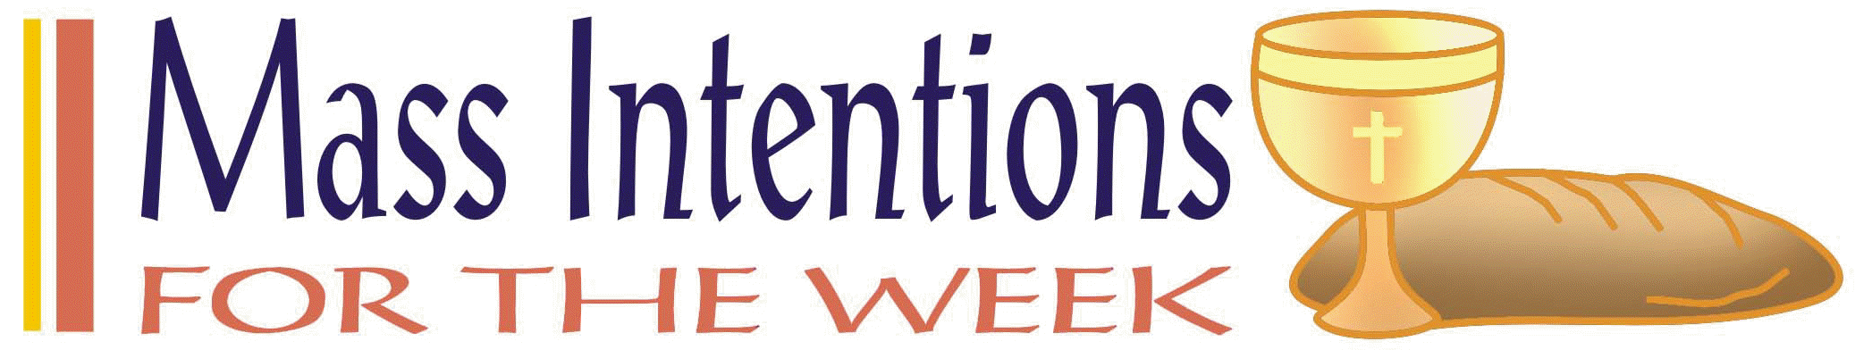

February 20: Charlotte Timmermann
Richard Ottensmeier
Bev Houseman

February 27: Ken Benhoff

VOCATION CORNERS
February 27: “During my younger years, the Lord allowed a lot of loneliness in my life. I was quiet and shy, and the church became my refuge; I always felt cared for by the priests and religious sisters there. I was intrigued by their joy and the presence of God so visible in them. This was something I wanted. I started going to adoration, where my faith and relationship with Jesus became my own. When I finished high school, I served as a missionary for a year and then decided to seriously discern religious life. Honestly, that time was hard; I didn’t know anyone else discerning or how to go about it….God continued to affirm my desire for this vocation. When I learn about the Benedictine way of life, I felt as if I were reading my own journal.
“Sr. Fidelis Marie Lanowich; Missionary Benedictine Sister, Sioux City, Iowa; Columbia Magazine Nov. 2021

It’s not too late! You can still subscribe to The Messenger using your subscription envelope; or call 618-233-8670. To subscribe online go to www.bellevillemessenger.org.

CONGRATULATIONS: We made our goal thru the Catholic Service and Ministry Appeal. If you have not given, please give if you are able. No amount is too small or too large and is important and needed. Contributions is excepted anytime through out the year.
______________________________________

Saint Liborius is having a Quilt of the Month Raffle beginning March 2022 thru February 2023. The winner of the montly drawing will have the option of that month’s designated quilt or $125.00. Tickets are $40.00 each. If interested in purchasing a ticket(s), please see bulletin board for additional information.

This Photo by Unknown Author is licensed under CC BY-NC-ND

WELCOME Maggie Jo Rensing, daughter of Joseph & Shelby Rensing who will be baptize here today after Mass.

Feb. 20: Breese Knights of Columbus Chicken Dinner to support All Saint Academy from 3 p.m. to 6 p.m. Carryout only. Meal include Chicken, dressing, mashed potatoes, green beans and slaw.
Feb. 27: Breese American Legion Chicken Dinner from 11 a.m. – 6 p.m. Drive thru or carryout. Meal consist of Chicken, mashed potatoes, gravy, dressing, green beans, coleslaw. $12.00
_____________________________________

The National Shrine of Our Lady of the Snow is offering a program called Religions in America, Mar. 12, 19, 26, and April 2 & 9, 10 a.m. – 12 noon. Cost is $50.00 for series and $10.00 per session. If interested, please additional information on bulletin board.
_____________________________________
Virtual Retreat will be hosted by St. Clare of Assisi Parish in O’Fallon, IL. The retreat starts March 13 and last one month. Additional information is on bulletin board.

Belleville Quest #146, Mar. 19 – 20, 2022 held at All Saints Academy in Breese, IL for Freshman and Sophomores. See Bulletin Board.

February 13: 9:30 a.m.
LECTOR: Ann Hampel
MINISTER OF HOLY COMMUNION: Lisa Voss
GIFT BEARERS: Mary & Alvin Huels family
SERVERS: PSR students
USHERS: Alan Heldorfer & Vince Langenhorst
MUSCIAN: Lisa McQuade

Please Update your contact information
Are your records current? Have you dropped your landline or changed your cell number? Have you moved, been married, divorced, or had a baby? Please help us keep our records up to date. Please take a form on table in back if your information has changed.

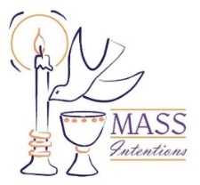
We welcome request for Mass Intentions
You can remember someone who has died recently or many years ago. But the intentions do not have to be just for the dead. They make beautiful gifts for any special occasion: birthdays, anniversaries, or even in thanksgiving. Mass intentions can be made by contacting the parish office or you may drop the following form along with payment in an envelope mark “Mass Intention” in the collection basket. Intentions are $10 per mass.
Dates are filling up so please get your Mass Intentions in to receive your special dates of your loved ones.

For: ___________________________________
Date requested: __________________________
Requested by: ___________________________
Phone Number: __________________________

February 6: 9:30 a.m.
LECTOR: Sue Potthast
MINISTER OF HOLY COMMUNION: Cindy Gnaedinger
GIFT BEARERS: Virginia & Jim Jansen
SERVERS: PSR class
USHERS: Alvin Huels and Craig Diekemper
MUSCIAN: Chad Schrage

January 9: 9:30 a.m.
LECTOR: Jackie Albers
MINISTER OF HOLY COMMUNION: Joe Luebbers
GIFT BEARER: Arlene Hilmes Family
SERVERS: PSR students
USHERS: Alan Heldorfer and Norb Rakers
MUSCIAN: Lisa McQuade

We welcome request for Mass Intentions
You can remember someone who has died recently or many years ago. But the intentions do not have to be just for the dead. They make beautiful gifts for any special occasion: birthdays, anniversaries, or even in thanksgiving. Mass intentions can be made by contacting the parish office or you may drop the following form along with payment in an envelope mark “Mass Intention” in the collection basket. Intentions are $10 per mass.
Most dates are open in 2022!!

For: ___________________________________
Date requested: __________________________
Requested by: ___________________________
Phone Number: __________________________

St. Rose Parish is having a Mission called “Come Back to Me with All Your Hearts”
and would like St. Felicitas Church to join in for an enjoyable, enlightening and will help to renew our Cathholic faith. Each evening will empower us to reconnect with our fellow parish community. All family members are welcome and encouraged to attend any or all the evenings. A social gathering will be held in the cafeteria following each service. Child care is provided (call Carolyn Alberternst at 618-210-4049 and it’s free). Speaker will be Redemptorist Father Peter Schavitz who is an excellent speaker. For more information, go to www.strosechurchil.org and pick up a brochure on table in back of church. Please let Barry or Deb know if you would like to attend.

JANUARY 2: 9:30 a.m.
LECTOR: Ann Hampel
MINISTER OF HOLY COMMUNION: Cindy Gnaedinger
GIFT BEARERS: volunteers
SERVERS: volunteers
USHERS: Barry Hampel and Vince Langenhorst
MUSCIAN: Chad Schrage

December 26: 9:30 a.m.
LECTORS: Millie Peppenhorst
MINISTERS OF HOLY COMMUNION: Joe Luebbers
GIFT BEARERS: Rakers family
SERVERS: volunteers
USHERS: Dan Potthast & John Hampel
MUSCIAN: Lisa McQuade

December 19: 9:30 a.m.

If you would like to be recognized for your birthday or anniversary in the weekly bulletin, please mark your special day in the calendar in the back of church

Volunteers are needed for the Annual Diocesan Christmas Dinner which will be held on Christmas Day. If interested, please see the Dec 5: 9:30 a.m.
LECTORS: Sue Potthast
MINISTERS OF HOLY COMMUNION: Cindy Gnaedinger
GIFT BEARERS: Kathy & Mary Gress
SERVERS: PSR Class
MUSICIAN: Chad Schrage

bulletin board for additional information.

December 12: 9:30 a.m.
LECTORS: Alayna Benhoff
MINISTERS OF HOLY COMMUNION: Jackie Albers
GIFT BEARERS: volunteers
SERVERS: PSR class
MUSICIAN: Lisa McQuade
USHERS: Alvin Huels & Dan Ketterer

November 21: 9:30
LECTORS: Jackie Albers
MINISTERS OF HOLY COMMUNION: Cindy Gnaedinger
GIFT BEARERS: Vince & Connie Barciszewski
SERVERS: PSR Class
MUSICIAN: Maribeth Detmer

November 28: 9:30 a.m.
LECTORS: Sharon Bickl
MINISTERS OF HOLY COMMUNION: Joe Luebbers
GIFT BEARERS: Potthast or Hampel family
SERVERS: volunteers
MUSICIAN: Maryibeth Detmer

This Photo by Unknown Author is licensed under CC BY-NC-ND

Please Update your contact information
Are your records current? Have you dropped your landline or changed your cell number? Have you moved, been married, divorced or had a baby? Please help us keep our records accurate. Please check the folder on the back table and let us know at the parish office by emailing: stfelbp@wisperhome.com. or drop an envelope in the collection basket with your correct information

Oblates Exhibit area at the Shrine of Our Lady of the Snows from November 19th thru December 31. This is also a great opportunity for youth service hours. If interested, please
email programs@snows.org or call 618-394-6281 snows,org/wol

- With whom will I stand in faith?
- How will I keep my eyes fixed on Jesus this day?
Fliers for the upcoming chicken dinner, which is, are available in the back of church.
Please take some and help spread the word.
Worklist and raffle tickets are also available,
please pick up your copy to help save with postage cost.
Also, please start saving your empty ice cream,
margarine, etc containers to use for leftover food.

Please pray for those who need the Lord’s healing in body, mind or spirit, especially Florence Huelsmann, Margie McQuade, Ramona Haislar, Taylor Marti, Gerald Hilmes, Ken Wellen,, Jim Jansen

Please Update your contact information
Are your records current? Have you dropped your landline or changed your cell number? Have you moved, been married, divorced or had a baby? Please help us keep our records accurate. Please check the folder on the back table and let us know at the parish office by emailing: stfelicitasbeaverprairie@gmail.com.

Please Update your contact information
Are your records current? Have you dropped your landline or changed your cell number? Have you moved, been married, divorced or had a baby? Please help us keep our records accurate. Please check the folder on the back table and let us know at the parish office by emailing: stfelbp@wisperhome.com. or drop an envelope in the collection basket with your correct information.

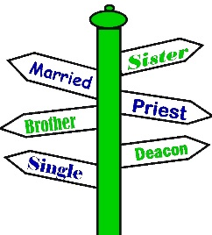

We welcome request for Mass Intentions
You can remember someone who has died recently or many years ago. But the intentions do not have to be just for the dead. They make beautiful gifts for any special occasion: birthdays, anniversaries, or even in thanksgiving. Mass intentions can be made by contacting the parish office or you may drop the following form along with payment in an envelope mark “Mass Intention” in the collection basket. Intentions are $10 per mass.
Available upcoming dates: Sept. 29; Oct. 6, 13 & 27

For: ___________________________________
Date requested: __________________________
Requested by: ___________________________
Phone Number: __________________________
If you have something you would like posted in the bulletin, please have it to the church office by Wednesday evening
via email to: stfelbp@wisperhome.com
or test Lisa by noon on Thursday

.

FATHER BRETT

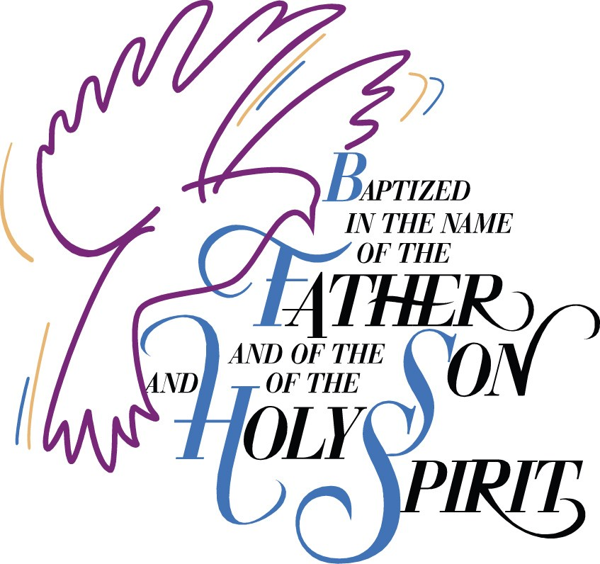

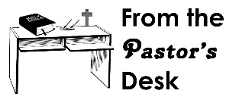

September 5: 9:30am
LECTORS: Millie Peppenhorst
MINISTERS OF HOLY COMMUNION: Lisa Voss
GIFT BEARERS: Monken’s family
SERVERS: Abby, Alex, Alayna, Mariah & Makenna
MUSICIAN: Lisa McQuade

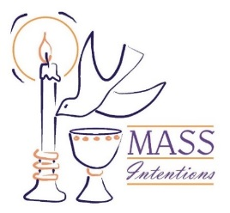
We welcome request for Mass Intentions
You can remember someone who has died recently or many years ago. But the intentions do not have to be just for the dead. They make beautiful gifts for any special occasion: birthdays, anniversaries, or even in thanksgiving. Mass intentions can be made by contacting the parish office or you may drop the following form along with payment in an envelope mark “Mass Intention” in the collection basket. Intentions are $10 per mass.

For: ___________________________________
Date requested: __________________________
Requested by: ___________________________
Phone Number: __________________________

