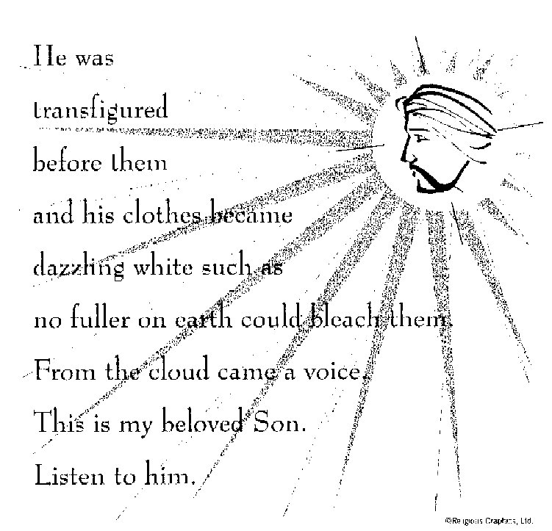

ST. ROSE CHURCH
ST. ROSE, IIlinois
Fr. Edward F. Schaefer
18010 St. Rose Road
526-4118 Rectory

SUNDAY MASS 10:00AM
SAT. VIGIL MASS 4:00PM
WEEKDAY MASS 7:45AM
RECONCILIATION Saturday: 3:15 – 3:45PM

WEBPAGE:: www.strosechurchil.com
EMAIL: belpsros@outlook.com
FACEBOOK: St. Rose Catholic Church – St. Rose, IL

MASS WILL BE LIVE STREAMED ON OUR FACEBOOK PAGE SATURDAYS AT 4PM

SUNDAY COLLECTIONS: Weekly Envelopes: $2,437.00
Sister Parish: $ 30.00
Black & Indian: $88.00 Capital Improvement Fund: $ 655.00
MASS INTENTIONS: MASS
Mon 7:45AM Lenten Weekday NO MASS
Tue 7:45AM St. Gregory of Narek NO MASS
Wed 7:45AM Lenten Weekday Rev. Dennis Voss
Wed 7:00PM Rev. John Quack
Thu 7:45AM Lenten Weekday NO MASS
Fri 7:45AM Lenten Weekday Jeanette Benhoff
Sat 4:00PM VIGIL: Third Sunday of Lent For the Parish
Sun 10:00AM Third Sunday of Lent Rev. Joseph Pingsterhaus
“ “ “ Jim Fuhler
“ “ “ Gervase “Gerp” Buehne

SERVERS:
Sat 4PM Alaina Schrage, Ava Tisher, Lexi Fuhler, Sam Fuhler
Sun 10AM Caitlyn Vonder Haar, Lauryn Vonder Haar, Lydia Thole, Cole Timmermann

READERS: Sat 4PM Jeff Kampwerth Sun 10AM Lisa Baer

EUCHARISTIC MINISTERS: Sat 4PM Jean Tebbe Sun 10AM Amanda Rauen & Melanie Rund

OFFERTORY: Sat 4PM Ralph Goebel, John Hustedde, Karl Klostermann
Sun 10AM Fuhler & Buehne Families

VOCATION CUP: The next family to receive the Vocation Cup is the Regan Bassick Family.

PLEASE WELCOME: Deacon Linus Klostermann who is helping with the Masses this weekend.

“HAVE YOU REMEMBERED ST. ROSE PARISH IN YOUR ESTATE PLANNING?”
ANNIVERSARY: Feb 26 Trevor & Sierra Koerkenmeier ’22 Feb 26 Bill & Amanda Rauen ‘11
Feb 29 Thomas & Kathleen Altgilbers ’60 Mar 03 Nathan & Emioly Gall ‘18

HAPPY BIRTHDAY:
Feb 27 Colby Detmer 17 Feb 28 Leona Thole Mar 02 Elizabeth Scott 18
Feb 27 Lydia Thole 14 Mar 01 Debbie Fuhler Mar 02 Lisa Smith
Feb 27 Chad Vonder Haar Mar 01 Tammy Kampwerth Mar 02 Dan Tebbe
Feb 28 Diana Dulle Mar 01 Jim Richter Mar 03 Jason Bange
Feb 28 Emma Heinzmann 5 Mar 02 Lillian Henrichs 16 Mar 03 Rylan Schneider 9
Feb 28 Kathleen Klostermann Mar 02 Marissa Jansen 14 Mar 03 Jennifer Schrage
Feb 28 James Kuper 12 Mar 02 Marilyn Rehkemper
Feb 28 Blake Monken 17 Mar 02 Lauren Schumacher

VOCATIONS:

SPECIAL VIDEOS ON JESUS AND THE EUCHARIST:
Plan to view the Special Videos on Jesus and the Eucharist produced by the Bishops of the United States for our National Eucharistic Revival. We will show them at 7:45PM in the 8th Grade Classroom in our school each Wednesday after Mass beginning THIS WEDNESDAY, Feb 21st.
(Please enter the school directly south of the south door of church by the convent entrance)
A great thing to do for your Lent! DON’T MISS IT!
A SEASON FOR REFLECTION: The Eucharist helps us to live in solidarity with our sisters and brothers around the world. Visit crsricebowl.org to learn more and read this week’s Story of Hope.
ST. ROSE CEMETERY CLEAN UP:
St. Rose Cemetery will be cleaned March 16-23. All Christmas, deteriorated, and broken decorations will be removed. If you wish to save any of these items, please remove them before
March 16th. Please remove grave blankets soon to avoid killing the grass.
NATIONAL BLACK AND INDIAN MISSION COLLECTION:
This weekend your support helps build the Church in African American, Native American & Alaska Native Communities. Please give as you are able.
SERRA CLUB OF ST. CLAIR COUNTY HOSTING AN EVENING WITH BISHOP MCGOVERN:
Tuesday, March 5th 6PM at St. Nicholas Parish, O’Fallon Bishop McGovern will celebrate a Mass
In the Parish Chapel. A light dinner & drinks in the Parish Hall at 6:30PM and remarks by Bishop McGovern on encouraging Vocations at 7PM. Evening is free but you do need reservations.
Contact Marvin Winkeler for more info mewinkel51@gmail.com or call/text 402-214-1155 or www.serrastclair.org.
SRDC FISH FRY: Friday, Feb 23 at the Park from 4PM to 7PM
HSHS ST. JOSEPH BREESE ANNUAL USED BOOK FAIR AND BAKE SALE:
February 29 – March 2 at the Breese KC Hall. Open at 10AM & close 7PM Feb 29 thru Mar 1.
and close at 5PM on March 2. Admission is $6 from 10-11AM Feb 29th and $3 from 11AM to 7PM.
See bulletin board for more information or call 618-526-5351 or Christine.gebke@hshs.org.

