ST. ROSE CHURCH St. Rose, IIlinois
Fr. Edward F. Schaefer
18010 St. Rose Road
526-4118 Rectory

SUNDAY MASS 10:00AM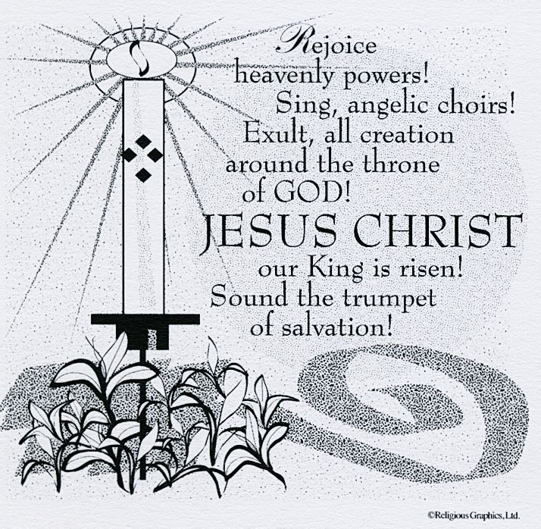
SAT. VIGIL MASS 4:00PM
WEEKDAY MASS 7:45AM
RECONCILIATION Saturday: 3:15 – 3:45PM
WEBPAGE: www.strosechurchil.com
EMAIL: belpsros@outlook.com
FACEBOOK: St. Rose Catholic Church – St. Rose, IL

MASS WILL BE LIVE STREAMED ON OUR FACEBOOK PAGE SATURDAYS AT 4PM

SUNDAY COLLECTIONS: Weekly Envelopes: $2,872.00
Holy Thursday $25.00 Easter $175.00 Capital Improvement Fund: $1,105.00
Sister Parish: $ 32.00

INTENTIONS: MASS
Mon 7:45AM Monday within the Octave of Easter No Mass
Tue 7:45AM Tuesday within the Octave of Easter No Mass
Wed 7:45AM Wednesday within the Octave of Easter No Mass
Thur 7:45AM Thursday within the Octave of Easter No Mass
Fri 7:45AM Friday within the Octave of Easter No Mass
Sat 4:00PM Vigil Second Sunday of Easter Mary Louise Wilke
“ “ “ Cletus Henrichs
“ “ “ William & Floriann Timmermann
Sun 10:00AM Second Sunday of Easter For the Parish

SERVERS: Sat 4PM Grayce Sturgeon, Ava Tisher, Landon Tebbe, Alaina Schrage
Sun 10AM Bella Thole, Noah Schuette, Addison & Brianna Tebbe

READERS: Sat 4PM Brenda Niedzwiecki Sun 10AM Pam Andrews

EUCHARISTIC MINISTERS: Sat 4PM Jean Tebbe Sun 10AM Jesse Tebbe

OFFERTORY: Sat 4PM Wilke, Henrichs & Timmermann Families
Sun 10AM Don Tebe, Rich Knebel, Mike Timmermann

VOCATION CUP: The next family to receive the Vocation Cup is the David Veizer Family.

EASTER MESSAGE FROM BISHOP MICHAEL MCGOVERN POSTED ON BULLETIN BOARD

MEALS ON WHEELS:
Anyone interested in delivering Meals on Wheels, please contact Ralph Bruggemann at
618-806-6730.

EASTER EGG HUNT THIS SUNDAY 11AM BEHIND CHURCH
SYMPATHY: Our sympathy to the family of Roger Henrichs. Roger, who passed away recently,
was the husband of Lorraine Henrichs and the father of Rodney (Angie) Henrichs, Yvonne
(friend, Mark Swinney)Shaw, Gina (Scott) Kuhn, and Bryan (Emily) Henrichs. He was the grandfather of Ashley (Ryan) Zurliene, Corynn & Carson Henrichs, Dylan, Austin, Kady & Kara Shaw, Tyler and Amanda Kuhn. He was the brother of Gervase “Gerp” (Dolores) Henrichs and the brother-in-law of Carleen (Carl) Rosen. May Roger enjoy the reward of eternal life.
CONGRATULATIONS: To Alyssa Koerkenmeier, who was voted the Belleville News-Democrat Girls
Basketball Player of the Year for 2022-2023! .
ST. ROSE SCHOOL: School Resumes Tuesday, Apr 11th.
HAPPY ANNIVERSARY: Apr 12 Omar & Edith Rojas ’03 Apr 13 Gary & Denise Vonder Haar ‘85
Apr 14 Ralph & Donna Tebbe ’78 Apr 15 Edward & Agnes Schrage ‘72
Apr 15 Steven & Donna Tebbe ’83 Apr 16 David & Darla Brinker ‘82
Apr 16 Michael & Margaret Detmer ’68 Apr 16 Daniel & Sandy Tebbe ‘94
Apr 16 Lucas & Alyssa Wilke ‘16
CONGRATULATIONS: To Steve & Donna Tebbe who are celebrating 40 years of marriage.
HAPPY BIRTHDAY:
Apr 10 Eric Benhoff Apr 12 Jacob Buehne Apr 15 Joseph Tebbe
Apr 10 Drew Buehne Apr 12 Sherry Wiegmann Apr 16 Henley Jo Buehne 4
Apr 10 Debra Buehne Apr 12 Asher Wiegmann 6 Apr 16 Kevin Burian
Apr 10 Mary Beth Faust Apr 13 Brian Dulle Apr 16 Timothy Koch
Apr 10 Jolyn Huelsmann Apr 13 Sarah Tebbe Apr 16 Jeffrey McCray
Apr 10 Colin Tebbe Apr 14 Kim Kueper Apr 16 Richard Rothengass
Apr 10 Ethan Tebbe Apr 14 Ashlyn Vonder Haar 19 Apr 16 Lidwina Schumacher
Apr 11 Stanley Essenpreis Apr 15 Kelsie Buehne
Apr 11 Payton Jeckstadt 21 Apr 15 Chad Tebbe
VOCATIONS:
Hallelujah!! He is Risen! All our souls have been redeemed. What a wonderful legacy!
We need to share this Redemption story with others – our Calling as Catholics.
This is what we commemorate through each celebration of the Eucharist which allows us to
receive our Lord in Holy Communion. We need to witness to this fact through our daily lives –
talking with our classmates, taking care of our spouses and children, engaging with our friends
and family, with our co-workers – in all we do! This is our vocation - a Call to Holiness.
HAPPY EASTER:
Our CRS Rice Bowl journey has ended. Let us hold in our hearts our sisters and brothers in
Honduras, the Philippines and Kenya and commit to share our Easter joy with people in our local
community and around the world. Don’t forget to turn in your CRS Rice Bowl by next Sunday
or donate online at crsricebowl.org/donate.
BREESE KC’S “THRILL OF THE GRILL”:
Sat, Apr 15th 11AM to 3PM
VIET NAM VETERANS OF AMERICA ALL YOU CAN EAT BREAKFAST:
Sunday, Apr. 16th 8AM to 11:30AM at Germantown American Legion
DAUGHTERS OF ST. PAUL VOCATIONAL DISCERNMENT RETREAT:
May 26 – 28.in St. Louis. If you are curious about a religious life and are a single Catholic woman
between the ages of 18-30 contact Daughters of St. Paul at connect.pauline.org/vocation-events.
ANNUAL “SPRING FARM BLESSING”:
Wednesday, Apr 26th at 1PM at the Paul & Jan Blankenberger Farm located in Enfield IL.
For more information, see bulletin board.
.
HAVE YOU REMEMBERED ST. ROSE PARISH IN YOUR ESTATE PLANNING?

.

