St. Felicitas Church
PRAYER REQUEST
Please pray for those who need the Lord’s healing in body, mind or spirit, especially Florence Huelsmann, Margie McQuade,
Ramona Haislar, Taylor Marti, Father Joe Rascher, Gerald Hilmes,, Fr. Dale Maxfield, Ken Wellen,, Jim Jansen, Jerome Jansen, Gene Bickle, Ed McQuade and all who asked for our prayers.

13322 Church Road
Carlyle, IL 62231
Phone: 594-3040 Fax: 594-3040
stfelbp@wisperhome.com
Pastor
Fr. Ed Schaefer
_{Phone: 526-4118}
belpsros@papadocs.com

Father Tom Killian

Parish Pastoral Council: Justin Benhoff, Gene Bickl, Cindy Gnaedinger, Joe Luebbers, Don Marti
Finance Council: Mary Huelsmann, John Ketterer, Dan Potthast, Allen Thole and Margie McQuade.
Parish Trustees: Barry Hampel and Alan Heldorfer
Administrative Asst: Deb Rakers-618-594-3040 or cell 618-698-9141

third Sunday of easter
We are an Easter people. Whatever our circumstances may be, or the circumstances of the world, we gather today for joy because our Lord truly rose from the dead, conquering death and bringing the promise of eternal life. On Easter Sunday we renewed our baptismal promises affirming our faith, renouncing sin and evil, and promises to follow Christ in the newness of life. Let us lives our lives in the joy of the Resurrection and spread that joy to all we meet.
Our readings today take us back in time to the days that followed Jesus’ resurrection. Peter preached in the temple, promising forgiveness for those who have repent and convert. John wrote to the early Christian community, promising the love of God to those who keep the commandments. Before all this, Jesus appeared to his disciples, assuring them of his bodily presence and charging them to testify in his name to the whole world. Let us listen, knowing we are called to do the same.

Question of the Week

How can I give witness to the forgiveness I have experienced in Jesus

WEEKLY OFFERING

April 11, 2021
Number of Envelopes 17
Envelope Total……………..$512.00
Loose Collection…………….$50.00
Grand Total………………...$562.00

Rice Bowls………………….$114.00
Donations………………… $390.00
(Dolores Langenhorst)

Our monthly income for March 2021 was $3678.00 and monthly expenses was $5272.00.

Please give as you are able…

Thank you for your generosity

Liturgical Ministries

April 18: 9:30 A.M.
GREETER: Deb Rakers
LECTOR: Sue Potthast
SERVERS: Aden & Alex Voss
MUSICIAN: Mary Beth Detmer

April 25: 9:30 A.M.
GREETER: Deb Rakers
LECTOR: Jackie Albers
SERVERS: Maecie & Conner Carrillon
MUSICIAN: Lisa McQuade

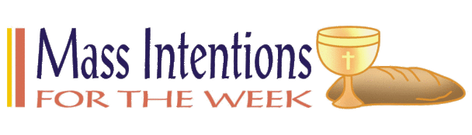

April 18: Cletus Ketterer; Kenneth Benhoff & Jim Lewis

April 25: Carroll, Shirley, & Ricky Meyer

This Photo by Unknown Author is licensed under CC BY-SA
Donna Luebbers: April 18
Joyce Strotheide: April 19
___________________________________

VOCATION CORNER – April
April 18: “I was 7 years old when I first thought about becoming a priest. But by the time I moved to the United States from Mexico at age 15, the priesthood was not in my plans…I pursued a career in criminal justice instead. God had other plans for me, though. The decision to enter seminary was not an easy one. I struggled with my own desires and with what other people thought would be best for me. Ultimately, I ran out of excuses and could no longer ignore the call that God had planted in my heart. If I had to do it all over again, I would answer the call without a doubt in mind.”
Fr. Francisco Javier Onate Vargas; Diocese of Charleston, S. C. Columbia Magazine September 2019
____________________________________________
CHAKOTA THERAPEUTIC CENTER: Spaghetti Dinner, Wednesday, April 21, 4:00 – 7:00. Dinner includes spaghetti with meat sauce, salad, breadsticks, and dessert. Adults is $10.00, Children is $5.00 (5 – 12) under 5 is free. Carry outs available. Also, Basket raffle and tickets to win a Smith & Wesson 357 Magnum (Model 686).
____________________________________
Thank you to all who were involved in a successful Drive thru Chicken Dinner, Total dinners were 1532!!!

In lieu of their annual Basket Bingo, the St Mary’s (Carlyle) Ladies Sodality will hold a raffle of a quilt, afghan, toaster oven, and 3 specialty baskets. Tickets are $1.00 each or six for $5.00 and may be purchased via the form in their bulletin and turned into their office, the collection basket, or mailed to Darlene Diekemper, 17017 Country Farm Rd, Carlyle, IL Tickets will also be sold after masses from April 10th until May 8th at St. Mary’s. To purchase tickets, please call Jane Beckmann at 618-791-7607. The drawing will be held after the 4 p.m. Mass on May 8th at St. Mary’s.
______________________________________


This Photo by Unknown Author is licensed under CC BY-NC-ND
High Honor Roll – District 12 – Maecie & Cara Carrillon
& Alex Voss.

Honor Roll – District 12 – Justin Hilmes, Connor Carrillon, Claire Luebbers & Abby Voss.

High Honor Roll - Central H. S. – Madison Diekemper

Honor Roll – Central H. S. - McKenzie Diekemper

High Honor Roll – All Saints - Mariah Benhoff

High Honor Roll – Mater Dei - Alayna Benhoff.

Honor Roll – Greenville Grade School – Annalisa Hilmes


This Photo by Unknown Author is licensed under CC BY-SA
CONGRATULATION TO BRENNA HILMES AND ALEX VONBOKEL ON THEIR MARRIAGE AT ST. MARY’S CHURCH, CARLYLE YESTERDAY.
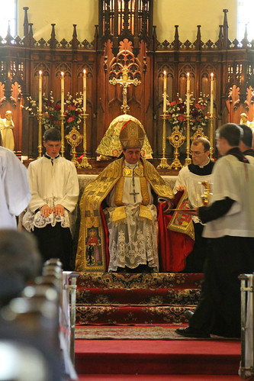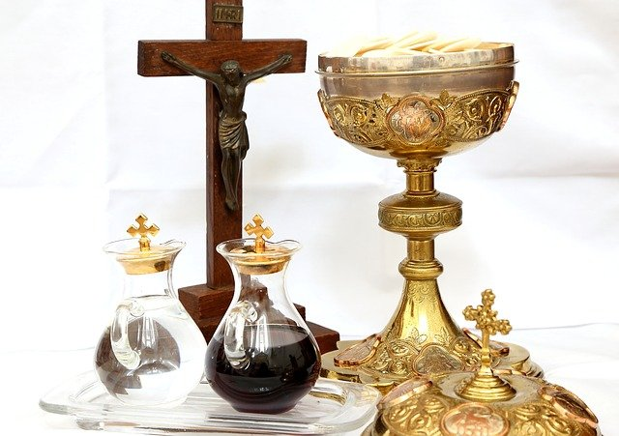
This Photo by Unknown Author is licensed under CC BY

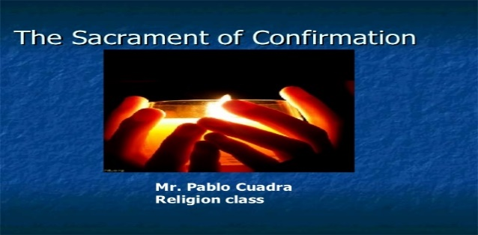
This Photo by Unknown Author is licensed under CC BY-NC-ND


improveme
nts and repair needs; and completing necessary repairs when appropriate. Building and grounds include church, rectory, parish center and cemetery. As Cemetery Sexton oversees all operations regarding the cemetery including but not limited to selling and recording burial permits and grave locations, opening and closing of graves, and placement of headstones. To apply send cover letter with résumé to St. Francis of Assisi Parish, PO Box 93, Aviston, Illinois 62216; email to parish@stfrancisav.org

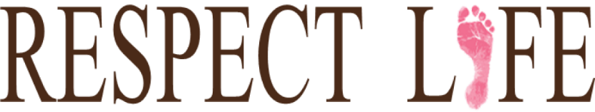
Please don’t forget to reserve your space for Mass. This will be first come, first-served basis. We definitely have more room for additional parishioners. So if you are able, please join us in prayer at our 9:30 Mass. Please call the office at 618-594-3040 or 618-698-9141 and leave a message or email stfelbpreservations@gmail.com

Anyone interested in Father’s Mike’s homily, please call his cell at 618-978-8767
or email hi
Mass Schedule for Easter Week:
Holy Thursday – April 1 at 6 p.m., Good Friday – April 2 at 4 p.m., Holy Saturday -April 3 at 6:30 p.m. and m at mhuss NO PSR CLASSES SUNDAY, MARCH 28TH AND SUNDAY, APRIL 4TH .

ey@stMessenger renewal and subscription can be made anytime throughout the year. The cost is $25.00. Payments can be made by via your Messenger envelope (also in the pews) or online at www.bellevillemessenger.org. Please consider subscribing or renewingenryoblates.org



