St. Felicitas Church
PRAYER REQUEST
Please pray for those who need the Lord’s healing in body, mind or spirit, especially Florence Huelsmann, Margie McQuade,
Ramona Haislar, Taylor Marti, Father Joe Rascher, Gerald Hilmes,, Fr. Dale Maxfield, Ken Wellen,, Jim Jansen, Jerome Jansen, Gene Bickl, Ed McQuade and all who asked for our prayers.

13322 Church Road
Carlyle, IL 62231
Phone: 594-3040 Fax: 594-3040
stfelbp@wisperhome.com
Pastor
Fr. Ed Schaefer
_{Phone: 526-4118}
belpsros@outlook.com

Father Tom Killeen

PASTORAL COUNCIL
Justin Benhoff, Gene Bickl, Cindy Gnaedinger, Joe Luebbers, Don Marti
Finance Council: Mary Huelsmann, John Ketterer, Dan Potthast, Allen Thole, and Margie McQuade.
Parish Trustees: Barry Hampel and Alan Heldorfer
Administrative Asst: Deb Rakers-618-594-3040 or cell 618-698-9141

Seventh Sunday of easter
Today is an unusual Sunday, for it falls between two important solemnities. Last Thursday we celebrated the Ascension , when Jesus ascended in glory to the Father. Next Sunday we will celebrate Pentecost, when the Father and the Son ‘s gift of the Holy Spirit descends upon the apostles. But this entire time we continue to celebrate the Easter season, our Lord’s victory over death and his promise of new life. Let us celebrate in Easter joy all that God has done for us.
Jesus prays to his Father in today’s Gospel, asking that all may be one. Peter invited the disciples to pray to ask the Lord to make their leadership—the apostles—whole again. (Twelve was symbolic of fullness and unity.) John tells us that God is love and love joins us to God. Let us pray that we too may find worthy leaders to guide us to Christian unity in God’s love.
Question of the Week

What specifically can I do this week to give of myself to someone else?

WEEKLY OFFERING

May 9, 2021
Number of Envelopes 31
Envelope Total……………..$1192.00
Loose Collection………………$40.00
Grand Total………………..$1232.00

Chicken Dinner……………..$9077.35

Our monthly income for April 2021 was $6703.00 and monthly expenses was $5425.00.

Thank you for your generosity

Liturgical Ministries

May 16: 9:30 A.M.
GREETER: Deb Rakers
LECTOR: Sue Potthast
SERVERS: Alayna & Mariah Benhoff
MUSICIAN: Maribeth Detmer

May 23: 9:30 A.M.
GREETER: Deb Rakers
LECTOR: Alayna Benhoff
SERVERS: Evie Albers & Abby Voss
MUSICIAN: Maribeth Detmer

May 16: Irvin & Trudy Luebbers

May 23: Successful crops

Allison VonBokel: May 17
Ken Wellen: May 18
Mark Hall: May 21
Wyatt Hampel: May 21
John Hampel: Belated May 13

Donna & Joe Luebbers – May 22 – 45 years
_________________________________

VOCATION CORNER – May
May 16 – “There was never a dull moment growing up with seven siblings. Little did I know that this experience would prepare me well for Benedictine life, life of stability in community lived in the enclosure of the monastery. Would I have become a monk if my grandmother had not prayed that one of her grandsons would become a priest; if my dad had not told me, “It doesn’t hurt to give God the first option”. Nothing is more beautiful than encountering Christ. I didn’t lose my family when I entered the monastery; I joined a family much larger than 10. I belong to God’s family.”
Fr. Caesarius Marple, OSB; Westminster Abbey, Mission, British Columbia; Columbia Magazine April 2020
____________________________________

Knights of Columbus meeting May 18th at 7:30 p.m. at Bartelso basement bowling alley.

This Photo by Unknown Author is licensed under CC BY-NC-ND
Celebration of baptism after Mass today for:

Tyce Michael Gray, son of Zane & Nicole Gray and grandparents Jean & Mark Gray; Charlotte Joann Haas, Daughter of Jayme & Tracy Haas and grandparents Cindy & Steve Gnaedinger
_____________________________________

There will be a meeting concerning updating the cemetery guidelines. Tentative date will be
June 16 at 6 p.m. at the cemetery (dry weather permitting). Please try to attend!!
______________________________________

There are plenty of dates still open for Mass Intentions if interested in having a Mass for a loved one. Also, light a small candle for $l.00 in memory of someone special.
__________________________________

Please fill out the form concerning possible pictures to be taken for an update Church Directory. We need to determine if it is worthwhile setting dates for pictures.
Hopefully, we will have 100% interested.
____________________________________

RUMMAGE SALE: St. Augustine Parish Center, Thur., June 17 from 4 p.m. to 8 p.m. Fri. June 18, from noon to 8 p.m. Sat., June 19, from 9 a.m. to 12 p.m. ($3.00 brown bag all day). Additional information on bulletin board.

If you have a child graduating from High School this year, please take the form back of Church and return ASAP completed so we can get them to the Messenger.
____________________________________

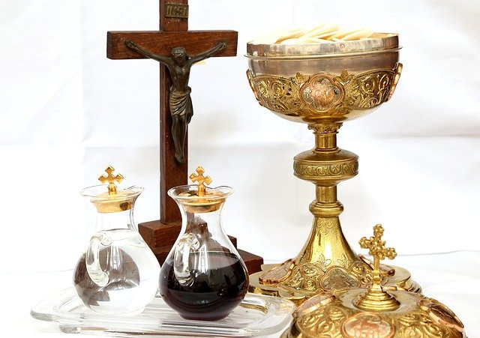

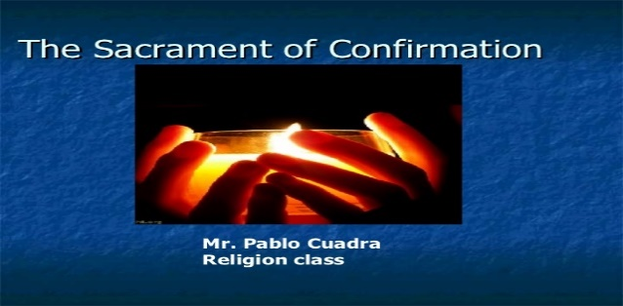
This Photo by Unknown Author is licensed under CC BY-NC-ND

improveme
nts and repair needs; and completing necessary repairs when appropriate. Building and grounds include church, rectory, parish center and cemetery. As Cemetery Sexton oversees all operations regarding the cemetery including but not limited to selling and recording burial permits and grave locations, opening and closing of graves, and placement of headstones. To apply send cover letter with résumé to St. Francis of Assisi Parish, PO Box 93, Aviston, Illinois 62216; email to parish@stfrancisav.org

Please don’t forget to reserve your space for Mass. This will be first come, first-served basis. We definitely have more room for additional parishioners. So if you are able, please join us in prayer at our 9:30 Mass. Please call the office at 618-594-3040 or 618-698-9141 and leave a message or email stfelbpreservations@gmail.com

Anyone interested in Father’s Mike’s homily, please call his cell at 618-978-8767
or email hi
Mass Schedule for Easter Week:
Holy Thursday – April 1 at 6 p.m., Good Friday – April 2 at 4 p.m., Holy Saturday -April 3 at 6:30 p.m. and m at mhuss NO PSR CLASSES SUNDAY, MARCH 28TH AND SUNDAY, APRIL 4TH .
ey@stMessenger renewal and subscription can be made anytime throughout the year. The cost is $25.00. Payments can be made by via your Messenger envelope (also in the pews) or online at www.bellevillemessenger.org. Please consider subscribing or renewingenryoblates.org

