ST. ROSE CHURCH St. Rose, IIlinois
Fr. Edward F. Schaefer
18010 St. Rose Road
526-4118 Rectory

SUNDAY MASS 10:00AM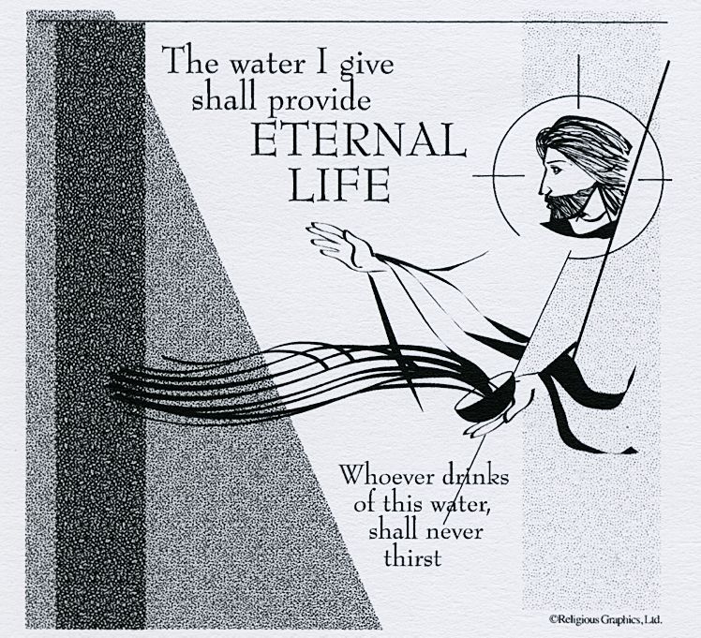
SAT. VIGIL MASS 4:00PM
WEEKDAY MASS 7:45AM
RECONCILIATION Saturday: 3:15 – 3:45PM
WEBPAGE: www.strosechurchil.com
EMAIL: belpsros@outlook.com
FACEBOOK: St. Rose Catholic Church – St. Rose, IL

MASS WILL BE LIVE STREAMED ON OUR FACEBOOK PAGE SATURDAYS AT 4PM

SUNDAY COLLECTIONS: Weekly Envelopes: $3,412.00
Black & Indian: $ 10.00 Capital Improvement Fund: $ 785.00
Sister Parish: $ 112.00
Catholic Relief Services: $ 10.00

INTENTIONS: MASS
Mon 7:45AM Lenten Weekday No Mass
Tue 7:45AM Lenten Weekday No Mass
Wed 7:45AM Lenten Weekday No Mass
Thu 7:45AM Lenten Weekday No Mass
Fri 7:45AM St. Patrick No Mass
Sat 4:00AM Vigil of the Fourth Sunday of Lent For the Parish
Sun 10:00AM Fourth Sunday of Lent Joe Fischer
“ “ “ Fr. Joe Rascher
“ “ “ Fr. Gary Gummersheimer

SERVERS: Sat 4PM: Kayley Burian, Wyatt Rauen, Marissa Jansen, Everett Jansen
Sun 10AM: Addison Thole, Wade Kramer, Briggs Kramer, Bella Thole

READERS: Sat 4PM: Bill Rauen Sun 10AM: Terry Kampwerth
EUCHARISTIC MINISTERS: Sat 4PM Tom Harper Sun 10AM: Rita Thole

OFFERTORY: Sat 4PM: Jeana Thole, Terry Snyder, Karl Klostermann
Sun 10AM: Fischer Family, Dale Timmermann, Brent Timmermann

VOCATION CUP: The next family to receive the Vocation Cup is the Tom Timmermann Family.

WELCOME: Please welcome back Fr. Nick Yunker who will be having the weekend Masses.

“HAVE YOU REMEMBERED ST. ROSE PARISH IN YOUR ESTATE PLANNING?”

CONGRATULATIONS
To the Mater Dei Knights girls basketball team who won the Class 2A girls Championship.
CONGRATULATIONS:
To Alyssa Koerkenmeier who had 23 points, 14 rebounds and 10 blocks in what is believed to be the first triple-double in girls state tournament history.
HAPPY ANNIVERSARY:
Mar 14 Anthony & Susan Tebbe ‘75 Mar 18 Randy & Michelle Buehne ‘89
HAPPY BIRTHDAY:
Mar 13 Darla Brinker Mar 16 Cory Schneider Mar 19 Linda Sandelin
Mar 13 Terry Kampwerth Mar 16 Kenny Thole Mar 19 Rose Strieker
Mar 13 Chase Richter 14 Mar 18 Jerry Huelsmann Mar 19 Brett Tebbe
Mar 16 Craig Becker Mar 19 Dakota Fehrmann
CSMA UPDATE: So far 49 families have pledged a total of $8,958.00.
VOCATIONS:
. “Father Pat York is the Dean of Students and Vice-Rector at Conception Seminary College. Father Pat recalls he
considered the priesthood during his eighth grade year. He credits his parents as having the biggest influence on his
priestly vocation. They encouraged their children to be open to God’s call as a priest or religious in the Church.
The seed of his vocation took root in his family and grew from there. He would ask his parishioners,
“Pray for the priests of our diocese. Support your parish priests. Pray fervently to the Lord for more
religious vocations.” Fr. Pat also encourages parents to set an example for their children in practicing their faith,
“Do not treat it as a burden or obligation, but as a gift that is enriching.”
The Tower Topics, by Fr. Paul Sheller, O.S.B.)
ST. ROSE WEDNESDAY LENTON HOLY HOUR:
This Wednesday at 7PM Reflections on parts of the Mass and Holy Hour Adoration will be held.
This week will include prayers for the protection of the unborn.
FROM FARMING TO FISHING:
Raul and Rhodora were coconut farmers in their town in the Philippines but it took a lot of work
before they made money. They participated in a Catholic Relief Services program that helped
them build their own fishpond to raise and sell fish. The fish provide nutritious food for their
family and more accessible income, enabling Raul and Rhodora’s granddaughters to attend school.
Visit crsricebowl.org to learn more
LENTEN RECONCILIATION:
St. Bernard, Albers Sunday, March 19th 1PM
St. Francis, Aviston Sunday, March 26th 3PM
St. Lawrence, Sandoval Sunday, March 26th 2PM
St. Mary, Carlyle March 26th 3PM
St. Mary, Centralia March 30 12:30PM (school)
LADIES SODALITY MEETING:
Next Sunday, March 19th @ 11AM in the cafeteria
ST. GEORGE PARISH DRIVE THRU CHICKEN DINNER:
THIS Sunday, March 12th 3PM to 6:30PM
ILLINOIS MARCH FOR LIFE:
Tuesday, March 21st in Springfield.
10AM Mass at Sangamon Auditorium #1 University Plaza
12PM Eucharistic Adoration Cathedral of Immaculate Conception, 524 E. Lawrence St.
12PM Rally at Capitol Building & 1PM March around Capitol Building, 401 S. 2nd. St.
CRAFT & BAKE SALE:
March 25th and 26th after Mass in the cafeteria. Homemade crafts designed by the PSR students.
All proceeds will go to our Mission Parish for a new guitar or keyboard.

DAYLIGHT SAVINGS TIME BEGINS THIS WEEKEND. Don’t forget to set your clocks forward 1 hour!

