St. Felicitas Church
PRAYER REQUEST
Please pray for those who need the Lord healing in body, mind or spirit, especially Florence Huelsmann, Margie McQuade, Ramona Haislar, Taylor Marti, Gerald Hilmes, Ken Wellen, Jim Jansen,
Jerome Jansen, Ed McQuade
and all who asked for our prayers.
Fr. Dale Maxfield, and all who asked for our prayers.

13322 Church Road
Carlyle, IL 62231
Phone: 594-3040 Fax: 594-3040
stfelbp@wisperhome.com

Father Ed Schaefer
belpsros@outlook.com
Cell: 618-526-4118

Father Tom Killeen

Parish Pastoral Council: Justin Benhoff, Gene Bickl, Cindy Gnaedinger, Joe Luebbers, Don Marti
Finance Council: Mary Huelsmann, John Ketterer, Dan Potthast, Allen Thole and Margie McQuade.
Parish Trustees: Barry Hampel and Alan Heldorfer
Administrative Asst: Deb Rakers 618-698-9141 or 618-594-3040

Twenty-third Sunday in Ordinary Time
On this Labor Day weekend, let us take a welcome rest from our labors—be they in a factory or field, store or office, school or home—and appreciate the time we take with the One who promised that his yoke was easy and his burden light. Today let us pray especially for those whose own burden is difficult: those who need to work more than one job to support their families, those who do not receive the gratitude and compensation they deserve for their work, and those who are unemployed or underemployed.
Our God is a transformative God, bringing life to the wasteland and giving hope to people who appeared to be abandoned. Isaiah, the prophet and poet, spoke to a society that equated deficiency with sinfulness, prophesying that God would transform the deaf, the blind, the disabled, and the mute. Jesus does just that in the Gospel. In between, James calls us to change the way we judge strangers we encounter. Listening top today’s reading, note the transformation we witness.

Question of the week:
Am I open to hearing God’s word, even from unexpected sources? How do I live out my baptismal call to proclaim God’s word?
Taken from Pastoral Patterns

Our first PSR class is scheduled for Sunday, September 12. If you know of a child who plans on attending the program who has not in the past, please let Deb know immediately so books and supplies can be ordered and ready. (Meeting with PSR parents directly after Mass- downstairs.)

WEEKLY OFFERING
8-29-2021
Number of Envelope 36
Envelopes Total $1764.00
Loose Collection $50.00
Grand Total. $1814.00

Mass Intentions…………………….. $270.00
Cemetery……………………………… $220.00
Our monthly income for August 2021 was $6424.00 our monthly expenses totaled $9074.00. Please give as you are able.

Thank you for your generosity!

September 5: 9:30am
LECTORS: Millie Peppenhorst
MINISTERS OF HOLY COMMUNION: Lisa Voss
GIFT BEARERS: Monken’s family
SERVERS: Abby, Alex, Alayna, Mariah & Makenna
MUSICIAN: Lisa McQuade

September 12 9:30am
LECTORS: Sue Potthast
MINISTERS OF HOLY COMMUNION: Joe Luebbers
GIFT BEARERS: Mary & Alvin Huels
SERVERS: Conner, Macie, Cara, Maggie & Evie
MUSICIAN: Chad Schrage

September 5: Irvin, Trudy & Stanley Luebbers
September 12: Craig, Paul & Aggie Huels

We have a date set for October 4 for pictures to be taken for the directory. Everyone who has their picture taken will receive an 8x10 photo and a directory free of charge.
Scheduling can be done online or Deb after Mass.

This week’s birthdays:

Sept. 5: Michael Etter
Sept. 8: Virginia Jansen, Drew Potthast
Lester & Millie Peppenhorst September 11 – 56 years

If you would like to be recognized for your birthday or anniversary in the weekly bulletin, please mark your special day in the calendar in the back of church

____________________________

VOCATION CORNER

As our country honors Labor this weekend, we can rejoice in our Labor for the Lord. We dedicate ourselves to St. Joseph the worker during this year of St. Joseph. We reflect on how we are working to spread the Word and how we are promoting our Catholic Church. This is the vocation of ALL of us. We have our role in praising our God, in sharing our Faith and working on educating our families in the ways of the Lord. We need to encourage our family members to be attentive to their call-maybe even to the priesthood or religious life.
_________________________________________

If you have something you would like posted in
by Wednesday evening via email to stfelbp@wisper.com or text Deb by noon on Thursday.

RETURN, RENEW REJOICE! St. Dominic, Breese is hosting a parish mission Sept. 19-21 led by Fr. Tom Donaldson, a Redemptorist priest. As we return to church, please consider joining them for the mission. Childcare and transportation are available. Each evening will have a presentation starting at 6:30 p.m. followed by refreshments and fellowship. There will also be a presentation, fellowship, refreshments on Monday and Tuesday morning of the mission beginning at 8 a.m.
_____________________________________

.
19
We are planning a DRIVE-THRU only Chicken Dinner for Sunday, Sept. 19. Please mark your calendar now so we are sure to have plenty of help.

Sept. 8-National Shrine of Our Lady of the Snows -Guide Center: Free one hour suicide prevention training session and for those who have lost someone due to suicide. Registration can be made online at www.snows.org/vigil or call 618-394-6281. Training session 6 -7 p.m. Candlelight vigil 7:30 p.m.
Sept. 8-First United Methodist Church, Carlyle, chicken dinner held at the IGA Complex. Serving 10:30 a.m. – 1:30 p.m. Adults and carry-outs $10; ages 6 and under free.
September 9-Pro-Life Prayer Service at St. Bernards, Albers, from 7-8
Sept. 19-St. Felicitas Chicken Dinner -drive thru -11 a.m. – 5 p.m.
Sept. 21-Vendor Fair St. George Community Life Center, New Baden, 10 a.m. – 2 p.m. Sponsored by the St. George Family Life & Social Activities Committee.

The 2021 Catholic Service and Ministry Appeal

Whoever believes in me will do the works that I do – John 14:12
Griffin Center, an agency that receives funding from The Catholic Service and Ministry Appeal, provides after-school and summer programs free of charge to 450+ children who live in public housing. With an emphasis on learning, homework assistance, computer labs and tutoring, Griffin Center gives these youngsters a chance for a brighter tomorrow. Be a part of their dreams and make your gift to this year’s Appeal today!
__________________________________________________

Position Available thru the Diocese – Director of Respect Life Apostolate: If interested, please see bulletin board in the back of Church for qualifications and submitting resume.

- With whom will I stand in faith?
- How will I keep my eyes fixed on Jesus this day?
Fliers for the upcoming chicken dinner, which is Sept. 15, are available in the back of church.
Please take some and help spread the word.
Worklist and raffle tickets are also available,
please pick up your copy to help save with postage cost.
Also, please start saving your empty ice cream,
margarine, etc containers to use for leftover food.

Please pray for those who need the Lord’s healing in body, mind or spirit, especially Florence Huelsmann, Margie McQuade, Ramona Haislar, Taylor Marti, Gerald Hilmes, Ken Wellen,, Jim Jansen, Jerome Jansen, Gene Bickl, Ed McQuade, Wolters families and all who asked for our prayers.

Please Update your contact information
Are your records current? Have you dropped your landline or changed your cell number? Have you moved, been married, divorced or had a baby? Please help us keep our records accurate. Please check the folder on the back table and let us know at the parish office by emailing: stfelicitasbeaverprairie@gmail.com.

Please Update your contact information
Are your records current? Have you dropped your landline or changed your cell number? Have you moved, been married, divorced or had a baby? Please help us keep our records accurate. Please check the folder on the back table and let us know at the parish office by emailing: stfelbp@wisperhome.com.

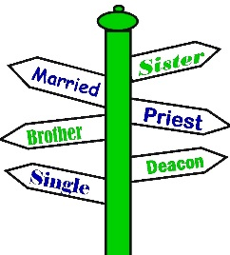

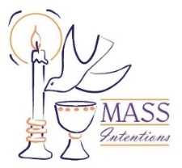
We welcome request for Mass Intentions
You can remember someone who has died recently or many years ago. But the intentions do not have to be just for the dead. They make beautiful gifts for any special occasion: birthdays, anniversaries, or even in thanksgiving. Mass intentions can be made by contacting the parish office or you may drop the following form along with payment in an envelope mark “Mass Intention” in the collection basket. Intentions are $10 per mass.
Available upcoming dates: Sept. 29; Oct. 6, 13 & 27

For: ___________________________________
Date requested: __________________________
Requested by: ___________________________
Phone Number: __________________________
If you have something you would like posted in the bulletin, please have it to the church office by Wednesday evening
via email to: stfelbp@wisperhome.com
or test Lisa by noon on Thursday

.

FATHER BRETT

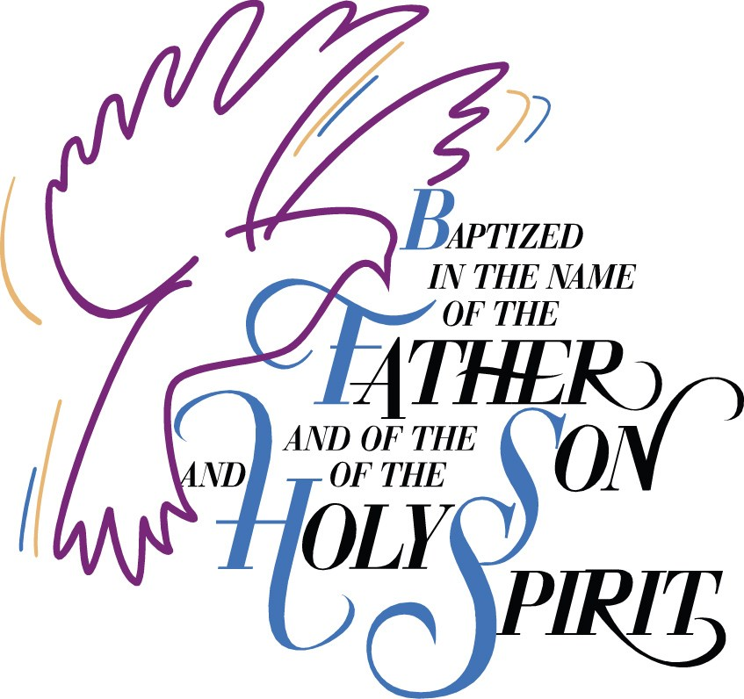

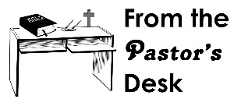

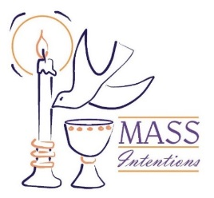
We welcome request for Mass Intentions
You can remember someone who has died recently or many years ago. But the intentions do not have to be just for the dead. They make beautiful gifts for any special occasion: birthdays, anniversaries, or even in thanksgiving. Mass intentions can be made by contacting the parish office or you may drop the following form along with payment in an envelope mark “Mass Intention” in the collection basket. Intentions are $10 per mass.

For: ___________________________________
Date requested: __________________________
Requested by: ___________________________
Phone Number: __________________________

August 25 9:30am
USHERS: Curt Carrillion & Matt Detmer
LECTORS: Geralyn Kruep
MINISTERS OF HOLY COMMUNION: Jeralyn VonBokel, Lisa Voss & Jackie Albers
GIFT BEARERS: --
SERVERS: Abby, Alex, Alayna, Mariah & Claire

September

September 1 9:30am
USHERS: Craig Diekemper & Steve Gnaedinger
LECTORS: Millie Peppenhorst
MINISTERS OF HOLY COMMUNION: Carly Etter, Cindy Gnaedinger & Ann Hampel
GIFT BEARERS: --
SERVERS: Alayna, Mariah, Cara, Conner & Macie

September 8 9:30am
USHERS: Barry Hampel & Alan Heldorfer
LECTORS: Sue Potthast
MINISTERS OF HOLY COMMUNION: Millie Peppenhorst, Bob Strotheide & Kris Strotheide
GIFT BEARERS: --
SERVERS: Dylan, Annalise, Claire, Abby & Alex

September 15 9:30am
USHERS: Alvin Huels & Dan Ketterer
LECTORS: Gene Bickl
MINISTERS OF HOLY COMMUNION: Jeralyn Von Bokel, Lisa Voss & Jackie Albers
GIFT BEARERS: --
SERVERS: Annalise, Dylan, Cara, Conner & Macie

September 22 9:30am
USHERS: John Ketterer & Glen Kruep
LECTORS: Sharon Bickl
MINISTERS OF HOLY COMMUNION: Gene & Sharon Bickl, Carly Etter
GIFT BEARERS: --
SERVERS: Abby, Alex, Alayna, Mariah & Claire

September 29 9:30am
USHERS: Vince Langenhorst & Joe Luebbers
LECTORS: Candace Detmer
MINISTERS OF HOLY COMMUNION: Cindy Gnaedinger, Ann Hampel & Mary Huelsmann
GIFT BEARERS: --
SERVERS: Alayna, Mariah, Cara, Conner & Macie

