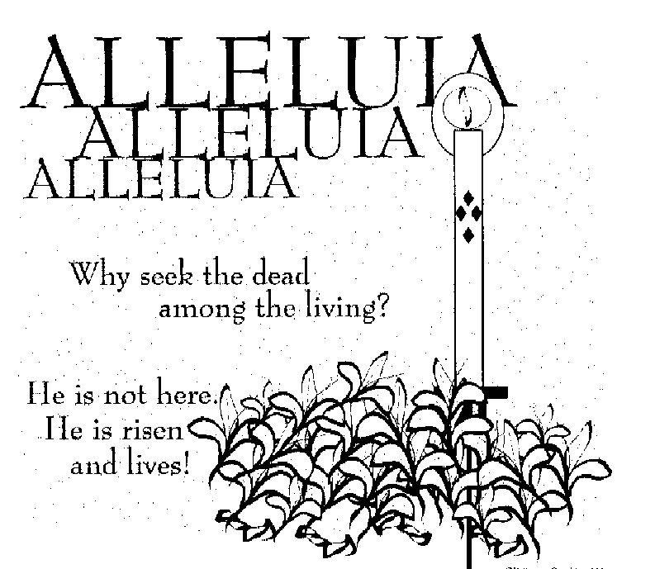

ST. ROSE CHURCH
ST. ROSE, IIlinois
Fr. Edward F. Schaefer
18010 St. Rose Road
526-4118 Rectory

SUNDAY MASS 10:00AM
SAT. VIGIL MASS 4:00PM
WEEKDAY MASS 7:45AM
RECONCILIATION Saturday: 3:15 – 3:45PM
WEBPAGE: www.strosechurchil.com
EMAIL: belpsros@outlook.com
FACEBOOK: St. Rose Catholic Church – St. Rose, IL

MASS WILL BE LIVE STREAMED ON OUR FACEBOOK PAGE SATURDAYS AT 4PM SUNDAY COLLECTIONS:
Weekly Envelopes: $4,889.00 Donations: $605.00 Sister Parish: $10.00
Easter: $875.00 Capital Improvement Fund: $760. Holy Land: $55.00

MASS INTENTIONS: MASS
Mon 7:45AM Monday within the Octave of Easter NO MASS Tue 7:45AM Tuesday within the Octave of Holy Week NO MASS
Wed 7:45AM Wednesday within the Octave of Holy Week Rev. James Dougherty
Thu 7:45AM Thursday within the Octave of Holy Week NO MASS
Fri 7:45AM Friday within the Octave of Holy Week John & Bea Tebbe
Sat 4:00PM Vigil Second Sunday of Easter L/D Ted & Mary Ann Tebbe Family
“ “ “ “ Stan & Mary Goestenkors
“ “ “ “ Aggie Svehla
Sun 10:00AM Second Sunday of Easter For the Parish
SERVERS: Sat 4PM Ava Tisher, Gavin Schneider, Rylan Schneider, Wyatt Rauen
Sun 10AM Caitlyn Vonder Haar, Lauryn Vonder Haar, Lydia Thole, Augie Benhoff

READERS: Sat 4PM Mary Lou Voss Sun 10AM Mabry Benhoff
EUCHARISTIC MINISTERS: Sat 4:00PM Carolyn Alberternst Sun 10AM Julie & Duane Bruggemann

OFFERTORY: Sat 4PM Tebbe, Goestenkors & Svehla Families
Sun 10AM Ralph Tebbe, Mike Timmermann, Ron Schrage

VOCATION CUP: The next person to receive the Vocation Cup is Austin Benhoff.

ST. ROSE LADIES SODALITY MEETING:
Sunday, April 7th after the 10AM Mass in the DEVELOPMENT CLUB.
New Officers are needed for the coming year.
ST. ROSE MENS SODALITY MEETING:
Sunday, April 14th after the 10AM Mass in the cafeteria.

“HAVE YOU REMEMBERED ST. ROSE PARISH IN YOUR ESTATE PLANNING?”

SYMPATHY: Our sympathy to the family of Bernard Wilke. Bernard, who passed away recently,
was the uncle of Alan Wilke & Kevin Wilke. May Bernard enjoy the reward of eternal life.

CONGRATULATIONS: To the following St. Rose Third Quarter Honor Roll Students:
Rylee Alberternst, Colton Diekemper, Kayley Burian, Danica Henrichs, Marissa Jansen, Landon Tebbe,
Lukas Winkeler, Abbigail Leezer, Ava Sidwell, Bryan Harrison, Ava Hilmes, Nolan Robke,
Brianna Tebbe, Cole Timmermann, Reagan Diekemper, Anna Henrichs, Everett Jansen,
Mandy Poettker, Senya Rahden, Gavin Schneider, Alaina Schrage, Raegan Alberternst,
Rory Fehrmann, Ruby Jansen, Aria Tebbe, Aubrey Thole, Gavin Leezer, Lena Otero, Wyatt Rauen,
Aubree Ribbing & Will Timmermann.
CONGRATULATIONS: To the following Central High School Third Quarter Honor Roll Students:
Peyton Markus, Rylan Segert, Elizabeth Snyder, Addison Tebbe, Loralei Schwierjohn, Mabry Benhoff,
Dalila Bjarro, Emily Cirrincione, Lillian Henrichs, Paige Kapp, Jacey Robke, Brooke Harrison, Morgan Kapp, Reed Segert, Laney Tebbe, Romayne Tebbe, Luke Tebbe, Austin Hilmes, Jonathan Koch,
Mallory Diekemper, Joseph Faust, Rylie Kluemke, Julie Kueper, Gavin Winkeler, Cole Kapp, and
Jaydon Tebbe.

ANNIVERSARY: Apr 5 Curt & Emily Strieker ’97 Apr 6 Wesley & Rachael Buehne ‘13
Apr 9 Craig & Robin Becker ‘94
CONGRATULATIONS: To Craig & Robin Becker who have been married 30 years!

HAPPY BIRTHDAY:
M Apr 1 Jan Tebbe Apr 4 Theodore Tebbe, Jr 10 Apr 6 Matthew Tebbe
Apr 1 Clara Tebbe 19 Apr 5 Thomas Thole Apr 6 Paul Thole
Apr 2 Rich Koerkenmeier Apr 6 Chelsey Henrichs Apr 7 Nathan Gall
Apr 4 Ada Butler 1 Apr 6 Rita Sidwell

VOCATION CORNER:
“I HALLELUJAH!! He is Risen! All our souls have been redeemed. What a wonderful legacy! We need to
share this Redemption story with others – our Calling as Catholics. This is what we commemorate through each celebration of the Eucharist which allows us to receive Our Lord in Holy Communion. We need to witness to this fact through our daily lives – talking with our classmates, taking care of our spouses and children, engaging with our friends and family with our co-workers – in all we do!
This is our vocation – a call to Holiness.

HAPPY EASTER:
As our CRS Rice Bowl journey comes to an end, may the Eucharist continue to transform our lives and
help us to respond to God’s call to serve our global family. Let us commit to sharing the joy of the
Resurrection with people in our local community & around the world. Don’t forget to turn in your CRS
Rice Bowl by next Sunday in the form of a check to “Catholic Relief Rice Bowl”.
2024 ST. ROSE DIRECTORY UPDATE:
There will be organization & group member photos taken, April 21st after 10AM Mass (i.e. Parish Council, Choir, Lectors, Ushers, etc.)
QUILTS FOR SALE AT ST. ANTHONY PARISH, BECKEMEYER:
Call Rosemary 618-444-1942, Florence 618-526-4466 or Betsy 618-978-2058

HAVE A HAPPY & BLESSED EASTER!
:

h

