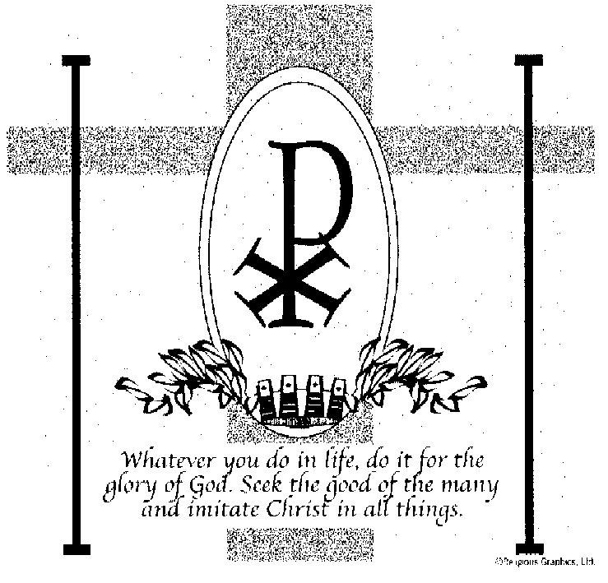

ST. ROSE CHURCH
ST. ROSE, IIlinois
Fr. Edward F. Schaefer
18010 St. Rose Road
526-4118 Rectory

SUNDAY MASS 10:00AM
SAT. VIGIL MASS 4:00PM
WEEKDAY MASS 7:45AM
RECONCILIATION Saturday: 3:15 – 3:45PM

WEBPAGE:: www.strosechurchil.com
EMAIL: belpsros@outlook.com
FACEBOOK: St. Rose Catholic Church – St. Rose, IL

MASS WILL BE LIVE STREAMED ON OUR FACEBOOK PAGE SATURDAYS AT 4PM

SUNDAY COLLECTIONS: Weekly Envelopes: $3,794.00
DONATIONS: $7,760.00 Sister Parish: $ 121.00
Capital Improvement Fund: $ 620.00
MASS INTENTIONS: MASS
Mon 7:45AM Weekday NO MASS
Tue 7:45AM Weekday NO MASS
Wed 7:45AM ASH WEDNESDAY Rose Rehkemper
Wed 7:00PM Ann Alberternst
Thu 7:45AM Thursday after Ash Wednesday NO MASS
Fri 7:45AM Friday after Ash Wednesday NO MASS
Sat 4:00PM VIGIL: First Sunday of Lent For the Parish
Sun 10:00AM First Sunday of Lent John Henrichs
“ “ “ Jim Tebbe
“ “ “ Marie Detmer

SERVERS: ASH WEDNESDAY 7PM Danica Henrichs, Marissa Jansen, Everett Jansen, Lydia Thole
Sat . 4PM Lexi Alberternst, Alexis Fuhler, Ali Butler, Lane Butler
Sun 10AM Grayce Sturgeon, Jacob Sturgeon, Nick Sturgeon, William Timmermann
READERS: ASH WEDNESDAY 7PM Mike Schumacher
Sat 4PM Peggy Thole Sun 10AM Kayden Barriger

EUCHARISTIC MINISTERS: ASH WEDNESDAY 7PM Carolyn Alberternst
Sat 4PM Gail Tebbe Sun 10AM Pat Henrichs & Avoynna Kampwerth
OFFERTORY ASH WEDNESDAY 7PM Alberternst Family
Sat 4PM Pete Jansen, John Kohlbrecher, David Thole
Sun 10AM Henrichs, Tebbe & Detmer Families

VOCATION CUP: The next family to receive the Vocation Cup is the Michael Barriger family.
PLEASE WELCOME: Deacon Linus Klostermann who is helping with the Masses this weekend.
CYM MEETING: Sunday, Feb 18th at 11AM in the Convent.
“HAVE YOU REMEMBERED ST. ROSE PARISH IN YOUR ESTATE PLANNING?”
SYMPATHY: Our sympathy to the family of Julia Von Wellen. Julia, who passed away recently,
was the sister of Bernell (Mary) Wellen and the sister-in-law of Pat Wellen. May Julia enjoy the reward
of eternal life.
SYMPATHY: Our sympathy to the family of Kent Fehrmann. Kent, who passed away recently, was the
brother of Keith (Tracy) Fehrmann, son-in-law of Pat Detmer and the brother-in-law of Diane Hempen,
and Rhonda (Ronnie) Becker. May Kent enjoy the reward of eternal life.
CONGRATULATIONS: To Sophia Thole, Paityn Fuhler, James Kuper & Cole Timmermann who
were named St. Rose School Wildcats of the Month.
ST. ROSE SCHOOL, MATER DEI HIGH SCHOOL CENTRAL HIGH SCHOOL
Fri., Feb 16 NO SCHOOL
ANNIVERSARY: Feb 18 Kyle & Megan Thole ‘17
HAPPY BIRTHDAY:
Feb 07 Blake Benhoff Feb 16 Mabry Benhoff 16 Feb 17 Lillyana Scott 20
Feb 13 Sean Alberternst Feb 16 Brett Huelsmann Feb 17 Abigail Timmermann
Feb 13 Patricia Vonder Haar Feb 16 Deb Knebel Feb 17 Evan Vonder Haar 10
Feb 15 Addison Hilmes 15 Feb 16 Ethan Schumacher Feb 17 Sharon Wiegmann
Feb 15 Rylie Kluemke 18 Feb 16 Scarlett Tehandon 6 Feb 18 Theresa Richter
Feb 15 Rhonda Schulte Feb 17 Ivan Benhoff 8 Feb 18 Vance Straeter
Feb 15 Joe Schwierjohn Feb 17 Jason Kapp Feb 18 Zoe Thole 3
Feb 15 Ava Sidwell 13 Feb 17 Robert Schumacher
VOCATIONS: A sage once wrote that a good marriage is like a fire around which others come to warm themselves. So, as we celebrate World Marriage Day on this Sunday, we realize that no matter our station in life - married, single or religious - we have benefited from this sacred covenant relationship whether through the example of our parents, grandparents, and other role models or through our own stewardship of the marriage covenant. For the Catholic steward, marriage goes far beyond the legal or societal agreement that our culture might define. Marriage brings us countless blessings but is met with many obstacles. Busy schedules, the challenges of parenthood, the strains of finances, mortgages, issued of health, and aging – all of these tests the bonds of even the finest unions.
DYNAMIC CATHOLIC LENT PROGRAM:
At critical times throughout Salvation History, God’s people have been invited to consecrate themselves.
We are one of those critical times, and consecrating ourselves, our families and our country to the Jesus in the Eucharist may make all the difference. Join Matthew Kelly for his: DYNAMIC CATHOLIC LENT PROGRAM for special daily Lenten E-mails starting Ash Wednesday.
CRS RICE BOWL:
Join our faith community in a transformative Lenten journey through CRS Rice Bowl to meet people in Uganda, El Salvador and Indonesia who are working hard to overcome the challenges of hunger & the impact of climate change. Pick up your family’s CRS Rice Bowl from church.
Visit crsricebowl.org to learn more.
CATHOLIC SERVICE & MINISTRY APPEAL (CSMA):
This weekend our parish, along with all other parishes in the diocese, will conduct our CSMA Appeal. This provides a convenient way for all of us, no matter what our time limitations, to take an active role in the mission of our diocesan Church. Please be as generous as you are able.
2024 PARISH DIRECTORY: Only February dates remain: Fri, Feb 16 & Sat Feb 17. Register On-line:
STEP 1: www.ucdir.com STEP 2: Click/Tap on Photography Appointment Scheduling STEP 3: Church Code: #348 Password: photos STEP 4: Click on date, STEP 5: Click on time: STEP 6: Enter information
SUBMITTED PHOTOS: Please contact Melisa Hemann 618-210-4887 Deadline for Submitted Photos (Feb 15) Any other questions, please call Jeff/Amy Kampwerth 618-406-6908
CATHOLIC FRATERNAL LIFE EUCHRE TOURNAMENT: THIS Sun., Feb 11th at 7PM
In the Development Club. Proceeds benefit Community Christmas Lighting Fund.
SRDC FISH FRY: Ash Wednesday, Feb 14th and Friday, Feb 16th at the Park from 4PM to 7PM

