ST. ROSE CHURCH St. Rose, IIlinois
Fr. Edward F. Schaefer
18010 St. Rose Road
526-4118 Rectory

SUNDAY MASS 10:00AM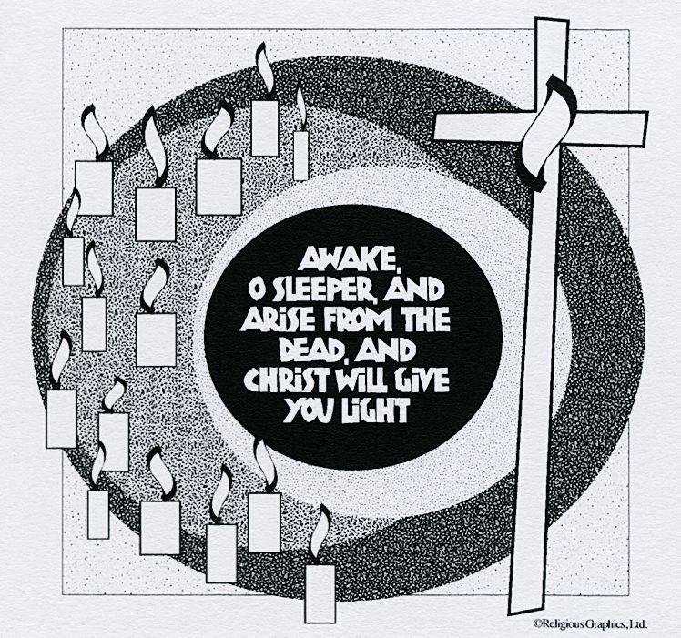
SAT. VIGIL MASS 4:00PM
WEEKDAY MASS 7:45AM
RECONCILIATION Saturday: 3:15 – 3:45PM
WEBPAGE: www.strosechurchil.com
EMAIL: belpsros@outlook.com
FACEBOOK: St. Rose Catholic Church – St. Rose, IL

MASS WILL BE LIVE STREAMED ON OUR FACEBOOK PAGE SATURDAYS AT 4PM

SUNDAY COLLECTIONS: Weekly Envelopes: $2,835.00
Capital Improvement Fund: $1,050.00
Sister Parish: $ 171.00

INTENTIONS: MASS
Mon 7:45AM St. Joseph No Mass
Tue 7:45AM Lenten Weekday No Mass
Wed 7:45AM Lenten Weekday No Mass
Thu 7:45AM St. Turibiusof Mogrovejo No Mass
Fri 7:45AM Lenten Weekday No Mass
Sat 4:00AM Vigil of the Fifth Sunday of Lent John & Bea Tebbe
“ “ “ “ Gerald Spihlman
“ “ “ “ Catholic Donor Extension Intention
Sun 10:00AM Fifth Sunday of Lent For the Parish

SERVERS: Sat 4PM: Rylan Segert, Landon Tebbe, Alaina Schrage, Chase Richter
Sun 10AM: Caitlyn & Lauryn Vonder Haar, Noah Schuette, Addison Hilmes

READERS: Sat 4PM: Jeff Kampwerth Sun 10AM: Lisa Baer
EUCHARISTIC MINISTERS: Sat 4PM Avery Rahden Sun 10AM: Jesse Thole
OFFERTORY: Sat 4PM: Tebbe & Spihlman Families & Matt Schrage
Sun 10AM: Dale Timmermann, Gary Tebbe, Tim Droege

VOCATION CUP: The next family to receive the Vocation Cup is the Bill & Sandy Timmermann Family.
WELCOME: Please welcome back Fr. George Benny who will be having the weekend Masses.

LADIES SODALITY MEETING
THIS SUNDAY, MARCH 19, 2023
11AM IN THE CAFETERIA

“HAVE YOU REMEMBERED ST. ROSE PARISH IN YOUR ESTATE PLANNING?”

THANK YOU:
A big “THANK YOU” To the Catholic Holy Family Society for their generous donation of $850.00
to the St. Rose PSR Program. It is greatly appreciated.
SYMPATHY:
Our sympathy to the family of Clara Knebel. Clara, who passed away recently, was the sister-in-law
of Mary Ann Grapperhaus. May Clara enjoy the reward of eternal life.
SYMPATHY: Our sympathy to the family of Thomas (Tom) Wilke. Tom, who passed away recently,
was the father of Alan Wilke & Kevin Wilke and the uncle of Jeannie (Marvin) Frohn and Geri Frohn.. May Tom enjoy the reward of eternal life.
MEN’S SODALITY NEW OFFICERS:
President, Brandon Fuhler, Vice President, Garrett Schrage, Treasurer, Matt Schrage and
Secretary is Mark Meyer. A big thank you to all the outgoing officers.
HAPPY ANNIVERSARY:
Mar 22 Kenny & Diane Thole ‘86 Mar 24 Daniel & Lisa Rehkemper ‘84
HAPPY BIRTHDAY:
Mar 20 Gabriel Rund Mar 23 Robert Fuhler Mar 25 Mary Jane Fuhler
Mar 20 Thomas Timmerman Mar 23 Collin Klostermann Mar 25 Brian Holtgrave
Mar 21 Lora Benhoff Mar 23 Mary Rehkemper Mar 25 Clarence Huelsmann
Mar 21 Andrew Strieker Mar 23 Grayce Sturgeon 13 Mar 26 Chad Ribbing
Mar 21 Kathryn Tebbe Mar 24 Matthew Schrage Mar 26 Karla Tebbe
Mar 21 Hunter Vonder Haar Mar 24 Jacob Thole 19
Mar 23 Kathryn Droege Mar 25 Joseph Cirrincione
VOCATIONS:
Sunday, (March 19) is the feast of the Solemnity of St. Joseph. “When Joseph awoke, he did as the
Angel of the Lord had commanded him.” (Matt 1:24) “It was grace that moved Joseph to embrace
his vocation as the guardian of Israel’s Messiah. It’s the same grace that empowers us to accept
God’s call and wisdom for our lives. Joseph’s yes in faith changed the world. God also has a plan
for your life. You don’t know where your yes might lead and how God might use it. Ask Joseph to
help. Then, like Joseph, go out in faith to be a “doer of the word” (James 1:22).” (The Word Among Us)
ST. ROSE WEDNESDAY LENTON HOLY HOUR:
Please join our WEDNESDAY HOLY HOUR WITH EUCHARISTIC ADORATION at 7PM in church, when we will pray for PEACE AND UNITY IN ALL OUR PARISH FAMILIES and IN FAMILIES EVERYWHERE.
SHARING SUCCESS:
Most people in Turkana, Kenya raise livestock, and a few are farmers. But the hot and dry climate makes this work difficult – and climate change is making it even harder. Rebecca & Lotiang participated in a Catholic Relief Services program that installed a water well and taught them new farming
Techniques. They are teaching others in their community what they learned. How can you use
Your knowledge to help others? Visit crsricebowl.org to learn more
LENTEN RECONCILIATION:
St. Bernard, Albers Sunday, March 19th 1PM St. Francis, Aviston Sunday, March 26th 3PM
St. Lawrence, Sandoval Sunday, March 26th 2PM St. Mary, Carlyle March 26th 3PM
PSR CRAFT & BAKE SALE:
Next weekend, March 25th and 26th after Mass in the cafeteria. Homemade crafts designed by the PSR students. All proceeds will go to our Mission Parish for a new guitar or keyboard.
ST. DAMIAN, DAMIANSVILLE HOLY NAME ANNUAL WURSTMARKT:
Sunday, March 25th in the Parish Gym from 10:30AM to 5:30PM. Dine in or carry out. $13 per dinner.
ST. ANNE CRADLE OF HOPE PRAYER SERVICE & DEDICATION:
Will be led by Bishop McGovern at the new Mother’s Care Center on Saturday, March 25th at 9AM.
2015 West Main St., Carbondale IL.

