**ST. ROSE CHURCH St. Rose, IIlinois**

**Fr. Edward F. Schaefer**

18010 St. Rose Road

526-4118 Rectory

**SUNDAY MASS 10:00AM**

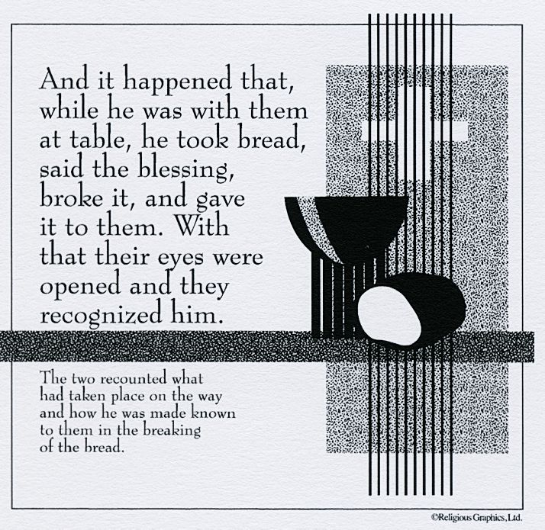

**SAT. VIGIL MASS 4:00PM**

**WEEKDAY MASS** **7:45AM**

**RECONCILIATION Saturday: 3:15 – 3:45PM**

**WEBPAGE**: [www.strosechurchil.com](http://www.strosechurchil.com)

**EMAIL: belpsros@outlook.com**

**FACEBOOK: St. Rose Catholic Church – St. Rose, IL**

**MASS WILL BE LIVE STREAMED ON OUR FACEBOOK PAGE SATURDAYS AT 4PM**

**SUNDAY COLLECTIONS:**

Weekly Envelopes: $3,842.00

Easter: $637.00 Capital Improvement Fund: $ 645.00

Holy Thursday: $5 Sister Parish: $ 52.00

**INTENTIONS**: **MASS**

Mon 7:45AM St. Fidelis of Sigmarigen No Mass

Tue 7:45AM St. Mark No Mass

Wed 7:45AM Easter Weekday No Mass

Thu 7:45AM Easter Weekday No Mass

Fri 7:45AM St. Peter Chanel & St. St. Louis Grigmion de Montfort No Mass

Sat 4:00PM Vigil Fourth Sunday of Easter For the Parish

Sun 10:00AM Fourth Sunday of Easter Rev. Edwin Kastner

“ “ “ Joe Fischer

“ “ “ Mary Schroer

**SERVERS**: Sat 4PM Wyatt Rauen, Raegan & Rylee Alberternst, Mandy Poettker

Sun 10AM Ruby Jansen, Senya Rahden, Ava Sidwell, Lydia Thole

***READERS****:* Sat 4PM Peggy TholeSun 10AM Mike Schumacher

**EUCHARISTIC MINISTERS:** Sat 4PM Linda Habermehl Sun 10AM Rose Rensing

**OFFERTORY:** Sat 4PM Mike Schrage, Bill Rauen

Sun 10AM Fischer & Schroer Families

**VOCATION CUP**: The next family to receive the Vocation Cup is the Taylor VonBokel family.

**CATHOLIC HOME MISSIONS APPEAL (CSMA)**: Next weekend we will take up the CSMA

Collection which generously supports ministries & programs of our Belleville Diocese each year.

Please give generously! For more info go to www.usccb.org/home-missions.

HAVE YOU REMEMBERED ST. ROSE PARISH IN YOUR ESTATE PLANNING?

**CONGRATULATIONS:** To Sadie Renee Schumacher who was Baptized here last weekend.

Sadie is the daughter of Brian and Alison (Kalmer) Schumacher. Many blessings to her!

**CONGRATULATIONS**: To Evan and Natalie (Horstmann) Schuette who were married here last

Weekend. Evan is the son of Cliff Schuette and Christy Schuette and Natalie is the daughter of

Matt & Betsy Horstmann. Many blessings to them!

**CONGRATULATIONS:** To the following students making their First Holy Communion at the 4PM Mass

this weekend: Landon Buehne, Lexi Butler, Coraleigh Diekemper, Mia Fuhler, Ellie Gall, Elijah Henrichs,

Asher Jansen, Lucinda Kuper, Ansly Mollet, Ainalee Poettker, Michael Ribbing, Nora Schuette,

Addisyn Tebbe, Macy Tebbe & ElsieThole. Many blessings to them!

**THANK YOU RECEIVED FROM SISTER PARISH:**

Father Edgar from our Sister Parish in Guatemala would like to thank the PSR teachers, students

and their families for their donation of $1200.00 raised through their bake sale and craft sale for a new

instrument for their parish.

**HAPPY ANNIVERSARY**:

Apr 24 Stan & Mary Essenpreis ’81 Apr 24 Greg & Kris Jeckstadt ‘99

Apr 24 James & Dolores Richter ’57 Apr 27 Thomas & Mary Jean Harper ’84

Apr 28 Daniel & Amanda Benhoff ’07 Apr 28 Jacob & Kelsie Buehne ‘18

Apr 28 Jason & Adrienne Scott ’12 Apr 29 Dan & Donna Boeing ‘95

Apr 30 Linus & Debra Buehne ’83 Apr 30 Lance & Amye Rahden ‘10

Apr 30 Chad & Stacey Ribbing ’11 Apr 30 Joseph & Jan Tebbe ‘76

**CONGRATULATIONS**: To Linus & Debra Buehne who are celebrating 40 years of marriage.

**HAPPY BIRTHDAY:**

Apr 22 Mary Wellen Apr 25 Brett Timmermann Apr 28 Corey Hilmes

Apr 23 Timothy Droege Apr 25 Kyle Vonder Haar Apr 28 Chrysa Tebbe

Apr 23 Tyler Kramer Apr 25 Virgil Voss Apr 28 Mary Veizer

Apr 23 Albert Tebbe Apr 26 Ryan Fuhler Apr 29 Warren Benhoff 4

Apr 24 Dallas Rehkemper 16 Apr 26 Noah Schuette 11 Apr 29 Anthony Rensing

Apr 26 Aubrey Richter 5 Apr 27 Kim Schneider Apr 30 Brooke Lane

Apr 30 Tinsley Schwierjohn 12

**VOCATIONS**:

“A difficult freshman year of high school left me feeling alone and far away from God,

in part because of my sins. I decided to do something different and attended a Catholic

youth conference. It was there that I heard Jesus say, “Estevan, you’re not just a face

in the crowd. I love you, and I’m calling you to be a saint.” From that moment on,

I sought to give my life to him. After graduating high school, I entered seminary.

The biggest thing I’ve learned is to lean into the Lord’s grace. No matter where your

discernment leads, open wide your heart to Christ, and he will not disappoint you.”

Fr. Estevan Wetzel; Diocese of Phoenix

**ANNUAL “SPRING FARM BLESSING”:**

Wednesday, Apr 26th at 1PM at the Paul & Jan Blankenberger Farm located in Enfield IL.

For more information, see bulletin board.

**ST. ANTHONY PARISH, BECKEMEYER RUMMAGE SALE:**

Apr 27th 9AM to 8PM Apr 28 9AM to 8PM Apr 29 9AM to 12PM

**ST. ANTHONY BECKEMEYER GRADE SCHOOL REUNION:**

Saturday, May 6, 2023. All classes from 1906 – 1994 is invited. Mass at 6PM followed by reception at the Parish Center. Cafeteria open to display memorabilia you would like to share. No food or drink

Available, but you are welcome to bring your own. Parish center doors open at 5PM More info on

Facebook @St.AnthonyCatholicSchoolBeckemeyerReunion.

.