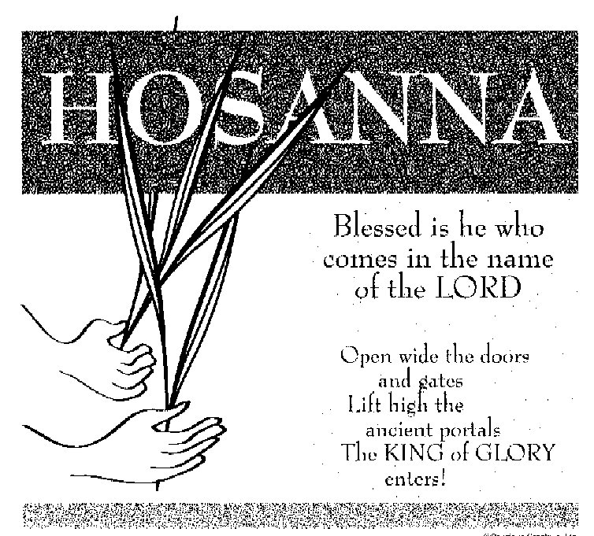

ST. ROSE CHURCH
ST. ROSE, IIlinois
Fr. Edward F. Schaefer
18010 St. Rose Road
526-4118 Rectory

SUNDAY MASS 10:00AM
SAT. VIGIL MASS 4:00PM
WEEKDAY MASS 7:45AM
RECONCILIATION Saturday: 3:15 – 3:45PM
WEBPAGE: www.strosechurchil.com
EMAIL: belpsros@outlook.com
FACEBOOK: St. Rose Catholic Church – St. Rose, IL

MASS WILL BE LIVE STREAMED ON OUR FACEBOOK PAGE SATURDAYS AT 4PM SUNDAY COLLECTIONS:
Weekly Envelopes: $3,501.00 Donations: $5,050.00 Sister Parish: $145.00
Easter: $75.00 Capital Improvement Fund: $370. Catholic Relief: $70.00 Holy Land: $25.00

MASS INTENTIONS: MASS
Mon 7:45AM Monday of Holy Week NO MASS
Tue 7:45AM Tuesday of Holy Week NO MASS
Wed 7:45AM Wednesday of Holy Week Rev. James Dougherty
Thu 7:00PM Holy Thursday Marie Straeter
Fri 7:00PM Friday of the Passion of The Lord NO MASS
Sat 8:00PM Holy Saturday For the Parish
Sun 10:00AM Easter Sunday of the Resurrection of the Lord Roger Henrichs
“ “ “ “ Francis Schaefer
“ “ “ “ Jim Tebbe

SERVERS: Wed 7:45AM Confirmandi HolyThursday 7:00PM Confirmandi
Good Friday 7:00PM Confirmandi Holy Saturday 8:00PM Confirmandi
Easter Sunday: 10:00AM Confirmandi

READERS: Holy Thursday 7:00PM Mike Schumacher
Good Friday 7:00PM Peggy Thole & Jeff Kampwerth Holy Saturday 8:00PM Bill Rauen & Myrt Rollins
Easter Sunday 10:00AM Brenda Niedzwiecki

EUCHARISTIC MINISTERS: Holy Thursday 7:00PM Gail Tebbe & Ed Schrage
Good Friday 7:00PM Karla Tebbe & Jean Tebbe
Holy Saturday 8:00PM Pat Henrichs & Julie Bruggemann
Easter Sunday 10:00AM Deb Wilke & John Kohlbrecher

OFFERTORY: Holy Thursday 7:00PM Straeter Family
Good Friday 7:00PM Allen Strieker, Paul Thole, Brent Timmermann
Holy Saturday 8:00PM Ed Schrage, Erick Baer, Tim Droege
Easter Sunday 10:00AM Henrichs & Tebbe Families

VOCATION CUP: The next family to receive the Vocation Cup is the Cameron Beer Family.

PASSION PLAY: The 7th Grade PSR Class will present the Passion Play on Monday, March 25th at 7:45AM and again at 6:00PM in the school gym.
CONGRATULATIONS: To the following Mater Dei Third Quarter Honors:
Alyssa Koerkenmeier, William Meyer, Claire Thole, Aftyn Vonder Haar, Nadia Baer, Lily Ann Goebel,
Addison Hilmes, Bella Thole and Colin Vonder Haar.
ANNIVERSARY: Mar 29 Ronald & Bonnie Wilke ‘80 March 31 Matthew & Lisa Schrage ‘89
HAPPY BIRTHDAY:
M Mar 25 Joseph Cirrincione 19 Mar 27 Joyce Korte Mar 29 Lance Rahden
Mar 25 Mary Jane Fuhler Mar 27 Layney Tebbe 16 Mar 29 Brooke Remmert
Mar 25 Brian Holtgrave Mar 29 Jack Bassick 3 Mar 29 Danny Schumacher
Mar 25 Clarence Huelsmann Mar 28 Pearl Rosen Mar 29 Kyle Thole
Mar 26 Chad Ribbing Mar 28 Hallie Tebbe 1 Mar 30 Reed Segert 16
Mar 26 Karla Tebbe Mar 28 Colin Vonder Haar 16 Mar 30 Karen Tebbe
Mar 27 Lexi Alberternst 11 Mar 29 Rylee Jo Alberternst 14 Mar 31 Dale Richter
Mar 27 Brooks Buehne 3 Mar 29 Jeffrey Buehne Mar 31 Henry Tebbe 8
Mar 27 Pat Henrichs Mar 29 Susan Goestenkors Mar 31 David Thole
VOCATION CORNER:
“I “I grew up in Haiti as the first child in a family of cradle Catholics. I heard stories about how my dad discerned the
priesthood before he married my mom & I witnessed the humanity of the religious sisters who
taught me in school. This faith-filled environment sowed the seeds of my religious vocations & as a young girl I believed I was called to be a sister. Years later, after my family settled in the United States,
I became a lost sheep on a college campus. In 2008 I began to go to daily Mass, participated in Eucharistic Adoration & found a spiritual director. My discernment journey took me to many communities until in 2010 I knew that the Lord was asking me to say “yes” to Him through the Sisters of Mary, Mother of the Church”. Sister Christiana Marie Rene; Sisters of Mary, Spokane Wash.
MODERN DAY SIMON OF CYRENE:
Palm Sunday marks the beginning of Holy Week. As we walk with Jesus this week, we remember the countless women, children & men who carry heavy crosses even today: crosses of hunger, of vulnerability to climate change or of a lack of resources. How – Like Simon of Cyrene – can you help to carry the crosses of our sisters & brothers in your local community & around the world?
Visit crsricebowl,org/holy-week to learn more.
SHADOW STATIONS OF THE CROSS:
Will be performed by the Papaya Youth Group from Pierron THIS Sunday, March 24th 7:30PM at St. Augustine Church in Breese.
2024 ST. ROSE DIRECTORY UPDATE:
There will be organization & group member photos taken, April 21st after 10AM Mass (i.e. Parish Council, Choir, Lectors, Ushers, etc.)
QUILTS FOR SALE AT ST. ANTHONY PARISH, BECKEMEYER:
Call Rosemary 618-444-1942, Florence 618-526-4466 or Betsy 618-978-2058
FATHERS & FRIENDS BREAKFAST THIS Sunday, March 24th from 8AM to 12 Noon
ST. FELICITAS, BEAVER PRAIRIE CHICKEN DINNER:
THIS Sunday, March 24th 11AM to 5PM
ST. DAMIAN, DAMIANSVILLE ANNUAL WURSTMART:
THIS Sunday, March 24th 10:30AM to 5:30PM in the Parish Gym.
GOLDEN AGE CARD CLUB:
Wednesday, March 27th at 1PM in the Development Club.
ST. ROSE LADIES SODALITY MEETING:
Sunday, April 7th after the 10AM Mass in the DEVELOPMENT CLUB.
New Officers are needed for the coming year.
:s “HAVE YOU REMEMBERED ST. ROSE PARISH IN YOUR ESTATE PLANNING?”

h

