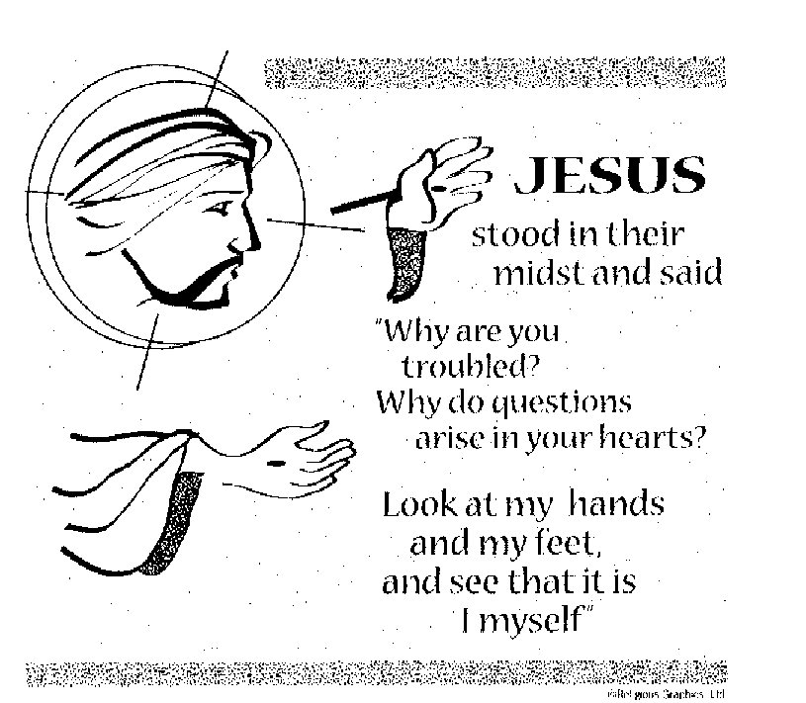

ST. ROSE CHURCH
ST. ROSE, IIlinois
Fr. Edward F. Schaefer
18010 St. Rose Road
526-4118 Rectory

SUNDAY MASS 10:00AM
SAT. VIGIL MASS 4:00PM
WEEKDAY MASS 7:45AM
RECONCILIATION Saturday: 3:15 – 3:45PM
WEBPAGE: www.strosechurchil.com
EMAIL: belpsros@outlook.com
FACEBOOK: St. Rose Catholic Church – St. Rose, IL

MASS WILL BE LIVE STREAMED ON OUR FACEBOOK PAGE SATURDAYS AT 4PM SUNDAY COLLECTIONS:
Weekly Envelopes: $4,255.00 Sister Parish: $111.00 Easter: $505.00 Capital Improvement Fund: $1,697.00 Holy Land: $ 20.00 Adults Rice Bowl: $ 93.50

MASS INTENTIONS: MASS
Mon 7:45AM Easter Weekday NO MASS Tue 7:45AM Easter Weekday NO MASS
Wed 7:45AM Easter Weekday Edwina Tebbe
Thu 7:45AM Easter Weekday NO MASS
Fri 7:45AM Easter Weekday Rev. James Dougherty
Sat 4:00PM Vigil Fourth Sunday of Easter Alfred, Lucy & Gary Korte
“ “ “ “ Butch & Joan Kohlbrecher
“ “ “ “ Gervase Buehne
Sun 10:00AM Fourth Sunday of Easter For the Parish

SERVERS: Sat 4PM Kelli Poettker, Kayley Burian, Lane Butler, Ali Butler
Sun 10AM Lillian Hilmes, Nick Sturgeon, Aubrey Thole, Addison Thole

READERS: Sat 4PM Bill Rauen Sun 10AM Mike Schumacher

EUCHARISTIC MINISTERS: Sat 4PM Linda Habermehl
Sun 10AM Jean Tebbe & Pat Henrichs

OFFERTORY: Sat 4PM Korte, Kohlbrecher & Buehne Families
Sun 10AM Carl Gall, Leon Langenhorst, Dennis Schumacher

VOCATION CUP: The next family to receive the Vocation Cup is the Daniel Benhoff Family.

ST. ROSE MENS SODALITY MEETING:
THIS Sunday, April 14th after the 10AM Mass in the cafeteria.

“HAVE YOU REMEMBERED ST. ROSE PARISH IN YOUR ESTATE PLANNING?”

CONGRATULATIONS: To Hayes Ryan Vonder Haar who was Baptized here last weekend.
Hayes is the son of Ryan and Noel (Loepker) Vonder Haar. Many Blessings to him!

SYMPATHY: Our sympathy to the family of Paul Rehkemper. Paul, who passed away recently,
was the brother-in-law of Joanne Rehkemper and Lorene Rehkemper. May Paul enjoy the reward of eternal life.

ANNIVERSARY:
Apr 15 Ed & Agnes Schrage ’72 Apr 15 Steve & Donna Tebbe ’83 Apr 16 Dave & Darla Brinker ‘82
Apr 16 Mike & Margie Detmer ’68 Apr 16 Dan & Sandy Tebbe ’94 Apr 16 Lucas & Alyssa Wilke ‘16
Apr 18 Eric & Beverly Faust ’00 Apr 19 Martin & Karen Schumacher ‘85
Apr 21 Adam & Julie Knebel ’18 Apr 21 Scott & Kristie Tebbe ‘01

HAPPY BIRTHDAY: Apr 14 Fr. Ed
Apr 15 Kelsie Buehne Apr 16 Jeff McCray Apr 18 Daniel Benhoff
Apr 15 Chad Tebbe Apr 16 Richard Rothengass Apr 19 Adam Niedzwiecki
Apr 15 Joseph Tebbe Apr 16 Ludwina Schumacher Apr 20 Alan Carrillon
Apr 16 Henley Jo Buehne 5 Apr 17 Cade Breed Apr 20 Debra Smith
Apr 16 Kevin Burian Apr 17 Brooke Buehne Apr 21 David Niedzwiecki
Apr 16 Timothy Koch Apr 17 Robert Ottensmeier Apr 21 Keith Rehkemper

VOCATIONS CORNER:
“A monastery is a place where God is sought. Yet, I have always been terrible at seeking. As a boy, I even once forgot to look for my grandmother in a game of hide-and-seek. When I first visited St. Benedict Abbey as a college student in 2013, I heard a call from Christ that I didn’t really understand at the time. I loved the liturgy, the fraternity, the whole daily life – but I couldn’t explain why I wanted to be here. I believe our Lord called me to seek him in the monastery by my prayer and work, and by charity to my brothers and our guests, ultimately to find him in eternity. Christ sometimes seems to hide himself and call out so that II will seek him more eagerly, but often he is simply hidden by my distractions. Despite my forgetfulness, I am encouraged by his constant reminders and his promise: “Seek and you will find” (Mt 7:7)” Bro. Jerome Daignault; St. Benedict Abbey, Still River, Mass

CYM BAKE SALE:
THIS Sunday, April 14th after Mass.
2024 ST. ROSE DIRECTORY UPDATE:
There will be organization & group member photos taken, April 21st after 10AM Mass (i.e. Parish Council, Choir, Lectors, Ushers, etc.)

VOICES OF SPRING: A VIENNESE KAFFEEKLATSCH:
Masterworks Children’s Chorus presents A delightful afternoon of celebrated classics by Strauss and other Viennese masters, with coffee and desserts on Sunday, April 21 at 3:00PM in the Heritage Hall
at St. Paul United Church of Christ in Belleville. (115 W B St,) Tickets available at www.singmasterworks.org or at the door.
EMMAUS DAYS:
Bishop Michael McGovern and the Diocese of Belleville invite you to Emmaus Days as the Diocese of Belleville celebrates the Eucharistic Revival. Sunday, July 7th at the National Shrine of Our Lady of the Snows and on Monday, July 8th at the Cathedral of St. Peter.

REV. PAT PETER OF ST. DOMINIC’S CHURCH IN BREESE RETIREMENT:
St. Dominic is hosting a Retirement Celebration for Fr. Pat on Saturday, May 4th.
They will celebrate Fr. Pat with an 8:00AM Golf Scramble at Bent Oak Golf Course and a noon Parish Outing at Miner’s Park. (Southside Park).More details to come.

:

h

