ST. ROSE CHURCH St. Rose, IIlinois
Fr. Edward F. Schaefer
18010 St. Rose Road
526-4118 Rectory

SUNDAY MASS 10:00AM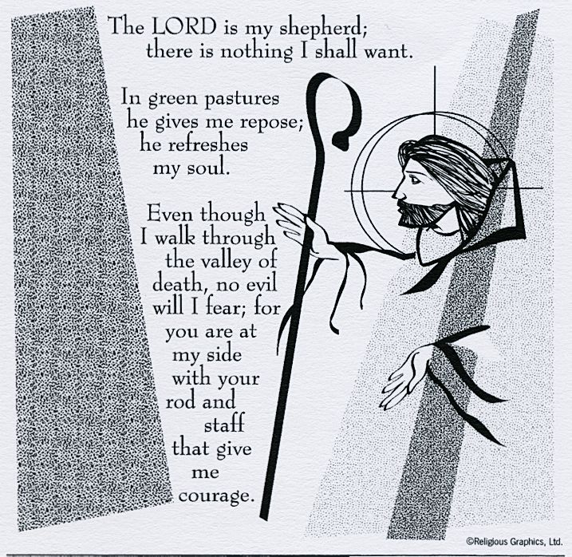
SAT. VIGIL MASS 4:00PM
WEEKDAY MASS 7:45AM
RECONCILIATION Saturday: 3:15 – 3:45PM
WEBPAGE: www.strosechurchil.com
EMAIL: belpsros@outlook.com
FACEBOOK: St. Rose Catholic Church – St. Rose, IL

MASS WILL BE LIVE STREAMED ON OUR FACEBOOK PAGE SATURDAYS AT 4PM

SUNDAY COLLECTIONS:
Weekly Envelopes: $4,663.00
Easter: $450.00 Capital Improvement Fund: $ 545.00
Holy Land: $100.00 Home Missions: $80.00 Sister Parish: $ 75.00

INTENTIONS: MASS
Mon 7:45AM St. Joseph the Worker No Mass
Tue 7:45AM St. Athanasius No Mass
Wed 7:45AM St. Philip & St, James No Mass
Thu 7:45AM Easter Weekday No Mass
Fri 7:45AM Easter Weekday Marie Straeter
Sat 4:00PM Vigil Fifth Sunday of Easter For the Parish
Sun 10:00AM Fifth Sunday of Easter Stan & Mary Goestenkors Family
“ “ “ Angie Foy
“ “ “ Brent Meyer

SERVERS: Sat 4PM Chase Richter, Ava Tisher, Gavin Schneider, Tinsley Schwierjohn
Sun 10AM Lukas Winkeler, Addison Thole, Caitlyn Vonder Haar, Bryna Harrison

READERS: Sat 4PM Bill Rauen Sun 10AM Pam Andrews

EUCHARISTIC MINISTERS: Sat 4PM Carolyn Alberternst Sun 10AM Ed Vonder Haar
OFFERTORY: Sat 4PM John Hustedde, Tom Harper & Terry Snyder
Sun 10AM Goestenkors, Foy & Meyer Families

VOCATION CUP: The next family to receive the Vocation Cup is the Craig Vonder Haar Family.

CATHOLIC HOME MISSIONS (CHM):
This weekend we will take up the collection for the Catholic Home Missions. This Appeal generously
supports ministires & programs of our Belleville Diocese. Please give generously.
.

HAVE YOU REMEMBERED ST. ROSE PARISH IN YOUR ESTATE PLANNING?

SYMPATHY:
Our sympathy to the family of Gerald Meyer. Gerald, who passed away recently, was the brother
of Paul (Lisa) Meyer, Marilyn (Jay) Fuhler, Angie (Dan) Diekmann and Mark (Stacey) Meyer.
He was the uncle of William & Cora Meyer, Brandon, Blake & Bailey Fuhler and Alex, Trent and
Erica Dieckmann. May Gerald enjoy the reward of eternal life.
CONGRATULATIONS:
To Beckett Henry Huelsmannn who was Baptized here last weekend. Beckett, is the son of
Brett and Jolyn (Vonder Haar) Huelsmann. Many Blessings to him!
CONGRATUATIONS:
To the St. Rose Wildcats of the month: Ansly Mollet, Ava Sidwell, Ruby Jansen and
Elizabeth Snyder.
CONGRATULATIONS:
To Central High School freshman Mabry Benhoff and the United States Youth Coed Cheerleading
Squad who claimed the International Cheer Union World Championship in Orlando Florida.
CONGRATULATIONS:
To Gavin Winkeler who was named Student of the Week for Central High School.
ST. ROSE SCHOOL:
Thursday, May 4th Spring Concert 7PM
Friday, May 5th Early Dismissal @ 11:45AM
HAPPY ANNIVERSARY:
May 1 Kurt & Justine Thole ’04 May 1 Craig & Chelsie Wiegmann ‘10
May 3 Duane & Patricia Poettker ’75 May 4 Brett & Chelsey Richter ‘13
May 4 Maurice & Sharon Wiegmann ’84 May 6 Daniel & Christa Trame ‘95
HAPPY BIRTHDAY:
May 1 Dan Boeing May 2 Matthew Rehkemper May 5 Jake Poettker 3
May 1 Danielle Buehne May 2 Elizabeth Thole May 6 Austin Hilmes 16
May 1 Karl Klostrmann May 3 Melissa Grapperhaus May 6 Blake Klenke
May 1 Steve Thole May 4 Jamie Buehne May 6 Leon Langenhorst
May 1 Ralph Voss May 4 Jessica Buehne May 7 Eric Bekcer
May 2 Gavynn Baer 19 May 4 Jonathan Koch 16 May 7 Trevor Koerkenmeier
May 2 Devon Frohn May 5 Ali Butler 12 May 7 Bella Thole 14
VOCATIONS:
Today we acknowledge the World Day of Prayer for Vocations. Will you make a special effort
to ask the Lord for vocations to the priesthood and religious life? Pray for the priests who have
ministered to you throughout your life, both living and dead. Encourage your children, grandchildren,
or other young people to consider a vocation as a priest or religious brother or sister. Pray a rosary for
more young men and women in our diocese to respond to God’s call. To quote Pope Francis,
“Each one of us is called – whether to the lay life in marriage, to the priestly life in the ordained ministry,
or to a life of special consecration – in order to become a witness of the Lord, here and now.”
FOOD FOR THE POOR MISSION TRIP TO JAMAICA:
June 12-15 or December 4-8. Food For The Poor mission trips allow you to see firsthand
The heartbreaking conditions that many of God’s children live in. Meet a family in need, build a house
in one day, serve a meal at a homeless shelter, visit a school and interact with the students, spend
time at a home for children with disabilities, fellowship with residents at a home for elderly and
disabled adults or visit an Angels Of Hope children’s home. During your Journey of Hope you will meet
in-country partners & spend time with beneficiaries of Food For The Poor projects., witnessing how
their lives are being transformed. The land package is $1150.00 per person and air fare is separate.
For more information, contact 800-568-8124 or www.foodforthepoor.com/missiontrip or email
missions@foodforthepoor.com

.

