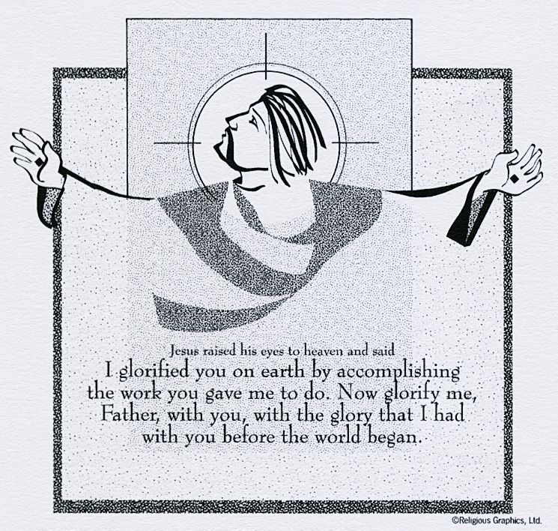
ST. ROSE CHURCH St. Rose, IIlinois
Fr. Edward F. Schaefer
18010 St. Rose Road
526-4118 Rectory

SUNDAY MASS 10:00AM
SAT. VIGIL MASS 4:00PM
WEEKDAY MASS 7:45AM
RECONCILIATION Saturday: 3:15 – 3:45PM
WEBPAGE: www.strosechurchil.com
EMAIL: belpsros@outlook.com
FACEBOOK: St. Rose Catholic Church – St. Rose, IL

MASS WILL BE LIVE STREAMED ON OUR FACEBOOK PAGE SATURDAYS AT 4PM

SUNDAY COLLECTIONS:
Weekly Envelopes: $4,267.00
Catholic Communications Fund: $60.00 Capital Improvement Fund: $ 520.00
Sister Parish: $ 92.00
INTENTIONS: MASS
Mon 7:45AM St. Rita of Cascia No Mass
Tue 7:45AM Easter Weekday No Mass
Wed 7:45AM Easter Weekday No Mass
Thu 7:45AM Easter Weekday No Nass
Fri 7:45AM St. Philip No Mass
Sat 4:00PM Vigil Pentecost JoAnn Vonder Haar
“ Catholic Extension Donor Intention “ Jeanette Rehkemper
Sun 10:00AM Pentecost For the Parish

SERVERS: Sat 4PM Rylan Segert, Landon Tebbe, Alaina Schrage, Kayden Barriger
Sun 10AM Caitlyn & Lauryn Vonder Haar, Noah Schuette, Bella Thole

READERS: Sat 4PM Mary Lou Voss Sun 10AM Myrt Rollins

EUCHARISTIC MINISTERS: Sat 4PM John Hustedde Sun 10AM Cora Meyer

OFFERTORY: Sat 4PM Vonder Haar Family & Rehkemper Family
Sun 10AM Pete Jansen, Michael Detmer, Carl Gall

VOCATION CUP: The next person to receive the Vocation Cup is Pat Vonder Haar.

THANK YOU:
The Mater Dei Late-Night Prom Festivities Organization would like to thank you for your generous
donation.

HAVE YOU REMEMBERED ST. ROSE PARISH IN YOUR ESTATE PLANNING?

ST. ROSE SCHOOL: Graduation Monday, May 22nd at 7PM. Last day of school is Tuesday, May 23rd.
CENTRAL HIGH SCHOOL: Graduation is Thursday, May 25, 2023
MATER DEI: Graduation is Friday, May 26th 2023
CONGRATULATIONS:
To Bella Thole, Addison Hilmes and Kayden Barriger who received scholarships to Mater Dei.
PARISH SCHOOL OF RELIGION:
PSR will be needing 3 new Religion Teachers (3rd grade, 5th grade and 6th grade) for the upcoming school year. If interested give Marilyn Bruggemann call 618-210-1258.
HAPPY ANNIVERSARY:
May 22 Leonard & Ruth Holtgrave ’71 May 22 Matthew & Judith Woltering ‘65
May 23 Larry & Barbara Harrison ’81 May 23 Scott & Amber Poelker ’09
May 23 Jerod & Brittany Sussen ’15 May 28 Galynn & Christine Gertsch ’94
May 28 Neil & Laura Lohman ‘16
HAPPY BIRTHDAY:
May 22 Peggy Schrage May 24 Trent Sidwell 19 May 26 Courtney Thole
May22 Judy Tebbe May 24 Marilyn Tebbe May 26 Jordan Timmermann
May 23 Charles Wesselmann May 24 Dane Thole May 26 Cheryl Timmermann
May 24 Michael Henrichs May 25 Jax Fuhler 6 May 26 Tina Voss
May 24 David Huelsmann May 25 Nicole Harrison May 28 Lexi Butler 8
May 24 Brandi Jansen May 25 Alison Schumacher May 28 Cody Grapperhaus
May 24 Jason Rakers May 26 Jordon Buehne May 28 John Hustedde
VOCATIONS:
“There was never a dull moment growing up with seven siblings. Little did I know that this experience would prepare me well for Benedictine life, a life of stability in community lived in the enclosure of the monastery. Would I have become a monk if my grandmother had not prayed that one of her grandsons would become a priest; if my dad had not told me, “”It doesn’t hurt to give God the first option””; Nothing is more beautiful than encountering Christ. I didn’t lose my family when I entered the monastery; I joined a family much larger than 10. I belong to God’s family.”
Fr. Caesarius Marple, OSB; Westminster Abbey, Mission, British Columbia
NOTE FROM BISHOP MCGOVERN:
Dear Friends in Christ,
I am inviting the faithful in our area to gather for Mass on the Feast of the Visitation of the Blessed
Virgin Mary, May 31, at 6PM at St. Clare Church in O’Fallon. The Visitation celebrates the meeting
of the Blessed Mother with her cousin St. Elizabeth as recorded in the Gospel of Luke (1:39-56).
This beautiful encounter of two women, each expecting a child, moves us to marvel with them at the gracious goodness of God who is the Author of all life. In this time when the sanctity of human life is
often disregarded, it is important for us to pray together for an increase in respect for human life at all
of its stages, with all of its vulnerabilities. Relying on the power of God, we affirm that every human
life should be cherished and respected from conception until natural death; hospitals and healthcare
Agencies should remain committed to preserving life, not ending it, and that the consciences of
Healthcare workers should be respected and protected so that they are never coerced into actions that
violate their spiritual core. Please join with me at St. Clare on May 31 at 6PM. May Jesus Christ, the
Bread of Life give us the strength we need to share the Gospel of Life with our families, friends and
neighbors.
INVITATION FROM BISHOP MCGOVERN:
“With great joy, I announce that on Saturday, June 3, 2023, I will ordain 14 men of our
Diocese to the Order of Deacon (Permanent Diaconate), The Liturgy will take place at the
Cathedral of St. Peter at 10:00AM. All are invited to attend. Please pray for our candidates
as they prepare for ordination.

