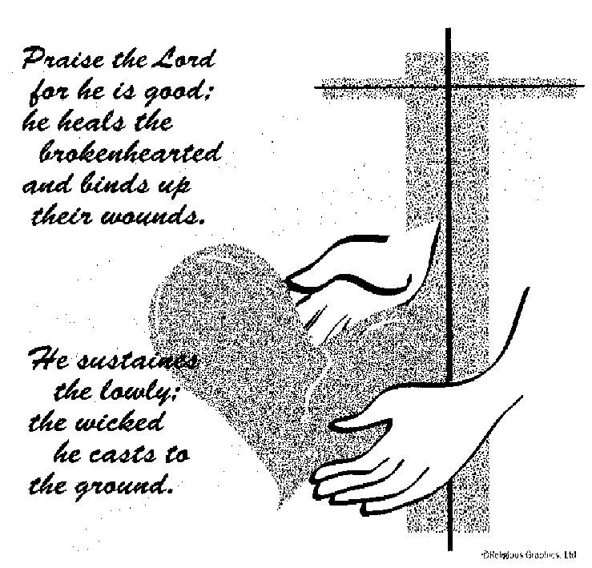

ST. ROSE CHURCH
ST. ROSE, IIlinois
Fr. Edward F. Schaefer
18010 St. Rose Road
526-4118 Rectory

SUNDAY MASS 10:00AM
SAT. VIGIL MASS 4:00PM
WEEKDAY MASS 7:45AM
RECONCILIATION Saturday: 3:15 – 3:45PM

WEBPAGE:: www.strosechurchil.com
EMAIL: belpsros@outlook.com
FACEBOOK: St. Rose Catholic Church – St. Rose, IL

MASS WILL BE LIVE STREAMED ON OUR FACEBOOK PAGE SATURDAYS AT 4PM

SUNDAY COLLECTIONS: Weekly Envelopes: $2,973.00
Sister Parish: $ 60.00
Capital Improvement Fund: $ 749.00
MASS INTENTIONS: MASS
Mon 7:45AM Saint Agatha NO MASS
Tue 7:45AM St. Paul Miki NO MASS
Wed 7:45AM Weekday Rev. Dennis Voss
Thu 7:45AM Sts Jerome Emiliani & Josephine Bakhita NO MASS
Fri 7:45AM Weekday Marie Straeter
Sat 4:00PM VIGIL: Sixth Sunday in Ordinary Time For the Family
Sun 10:00AM Sixth Sunday in Ordinary Time Bert Middeke
“ “ “ “ Gene Buehne
“ “ “ “ Jeanette Rehkemper

SERVERS: Sat . 4PM Landon Tebbe, Wyatt Rauen, Tinsley Schwierjohn, Alaina Schrage
Sun 10AM Caitlyn Vonder Haar, Lauryn Vonder Haar, Bryna Harrison, Ruby Jansen
READERS: Sat 4PM Mary Lou Voss Sun 10AM Lisa Baer
EUCHARISTIC MINISTERS: Sat 4PM Ed Schrage Sun 10AM Marilyn & Ralph Bruggemann
OFFERTORY: Sat 4PM Bill Timmermann, Mark Faust, Mike Detmer
Sun 10AM Middeke, Buehne & Rehkemper Families

VOCATION CUP: The next person to receive the Vocation Cup is Vince Barciszewski
PLEASE WELCOME: Deacon Linus Klostermann who is helping with the Masses this weekend.
MESSENGER SUBSCRIPTION RENEWAL WEEKEND:
Please stay connected with your Diocese through a subscription to the Messenger Catholic Newspaper. Payments can be made via your Messenger envelope or by credit card on line at www.bellevillemessenger.org & click SUBSCRIBE. $30 for printed, home-delivery, $25 for digital access & $35 for both. Make checks payable to THE MESSENGER!
CONGRATULATIONS: To Reaghan Tebbe who was named to the Dean’s List at Missouri State Univ. for the Fall Semester.
HAVE YOU REMEMBERED ST. ROSE PARISH IN YOUR ESTATE PLANNING?

CONGRATULATIONS: To Renee Steinmann who was named to the 2023 Greenville University
Fall Semester Dean’s List.
CONGRATULATIONS: To the following St. Rose Second Quarter Honor Roll Students:
Rylee Alberternst, Colton Diekemper, Danica Henrichs, Ella Henrichs, Mitchell Toennies, Riley Tucker,
Kayley Burian, Addison Cook, Marissa Jansen, Grayce Sturgeon, Landon Tebbe, Addison Thole,
Lydia Thole, Lukas Winkeler, Ava Sidwell, Bryna Harrison, Ava Hilmes, Nolan Robke, Brianna Tebbe,
Cole Timmermann, Reagan Diekemper, Anna Henrichs, Mandy Poettker, Senya Rahden, Gavin Schneider, Alaina Schrage, Emmett Toennies, Violet Tucker, Raegan Alberternst, Rory Fehrmann,
Ruby Jansen, Aubree Ribbing, Aubrey Thole, Lena Otero, Wyatt Rauen, Aria Tebbe and
Will Timmermann.
CONGRATULATIONS: To Abbi Kampwerth & Molly Detmer who were named to the 2023 Fall Semester President’s & Dean’s List at McKendree University.
CONGRATULATIONS: To Ella Klostermann who was 1 of 10 to receive a scholarship to the Southern Illinois Builders Association.
ST. ROSE SCHOOL: Tues. Feb 6 PTO & Booster Club Meeting 7:30PM
ANNIVERSARY: Feb 5 Daniel & Angela Diekmann ’94 Feb 9 Cody & Karlie Tebbe ‘19
CONGRATULATIONS: To Daniel & Angela Diekmann who are celebrating 30 years of marriage.
HAPPY BIRTHDAY:
Feb 05 Michelle Buehne Feb 08 Joanne Rehkemper Feb 11 Ryan Emig
Feb 05 Harlin Kramer 8 Feb 09 Pete Boeing Feb 11 Cole Kapp 18
Feb 05 Paul Rehkemper Feb 09 April Brinker Feb 12 Dave Boeschen
Feb 07 Allen Schrage Feb 09 Paityn Fuhler 10 Feb 12 Mandy Poettker 12
Feb 07 Katherine Thole Feb 10 Jay Detmer Feb 12 Barbara Rinderer
Feb 08 Marlene Holtgrave Feb 10 Galynn Gertsch Feb 12 Mark Tebbe
Feb 08 Terri Jansen Feb 10 Marie Henrichs
VOCATIONS: In 1997, Pope Saint John Paul II instituted a day of prayer for women and men in consecrated life. This celebration is attached to the Feast of the Presentation of the Lord on February 2nd (Candlemas Day). Let us make it a point to begin saying “THANK YOU” to our Sisters and Brothers who have made sacrifices for us by accepting God’s call. Let them know how important they are in the life of your church and how they help you to honor and pray to our Lord and Savior, Jesus Christ.
2024 PARISH DIRECTORY: Only February dates remain: Fri., Feb 16 & Sat Feb 17.
Register on line: STEP 1: www.ucdir.com STEP 2: Click/Tap on Photography Appointment Scheduling STEP 3 Church Code: il348 Password: photos STEP 4 Click on date. STEP 5 Click on time: STEP 6 Enter information. SUBMITTED PHOTOS: Please contact Melisa Heman at 618-210-4887.
Deadline for Submitted Photos is Feb. 15. Any other questions, please call Jeff/Amy Kampwerth at
618-406-6908.
CATHOLIC FRATERNAL LIFE EUCHRE TOURNAMENT: Sun., Feb 11th at 1PM
In the Development Club. Proceeds benefit Community Christmas Lighting Fund.
ST. DAMIAN CHURCH DAMIANSVILLE MEXICAN FISH FRY:
Friday, Feb 9th 4:30PM to 7:30PM in the Damiansville Gym. Mariachi Band 5-7PM
“BEAUTIFUL EUCHARIST!” You know the book you received on Christmas Day. It contains 13 personal reflections by thirteen very special people on Jesus in the Holy Eucharist. How many have you read so far? Which one helped you see the Holy Euchrist in a new way? Email your thoughts to
myrtrollins@gmail.com. You’re Adult Faith Formation Team would really like to know.
ST. ROSE DEVELOPMENT CLUB EUCHRE TOURNAMENT:
This Sun., Feb 4th at 7PM in the Development Club.
ST. VINCENT DE PAUL NEEDS YOUR HELP! The cupboards are bare and record numbers of people are staying at its OverNite Center and currently feeding 300+ people a day at Cosgrove’s Kitchen.
For information on how to help, see bulletin board or call 618-394-0126.

