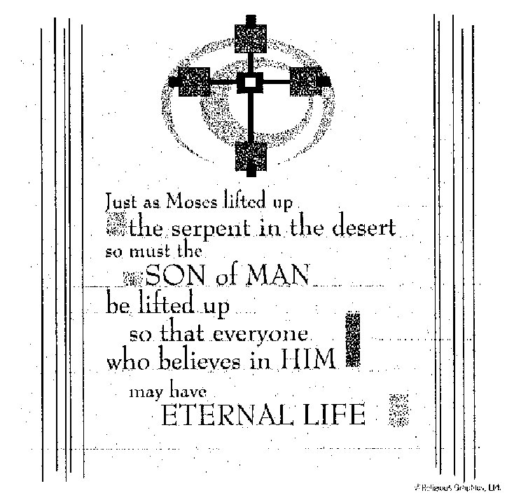

ST. ROSE CHURCH
ST. ROSE, IIlinois
Fr. Edward F. Schaefer
18010 St. Rose Road
526-4118 Rectory

SUNDAY MASS 10:00AM
SAT. VIGIL MASS 4:00PM
WEEKDAY MASS 7:45AM
RECONCILIATION Saturday: 3:15 – 3:45PM

WEBPAGE: www.strosechurchil.com
EMAIL: belpsros@outlook.com
FACEBOOK: St. Rose Catholic Church – St. Rose, IL

MASS WILL BE LIVE STREAMED ON OUR FACEBOOK PAGE SATURDAYS AT 4PM

SUNDAY COLLECTIONS: Weekly Envelopes: $3,363.00
Sister Parish: $ 115.00
Capital Improvement Fund: $1,002.00 Catholic Relief: $ 2.00 Black & Indian $ 25.00

MASS INTENTIONS: MASS
Mon 7:45AM Lenten Weekday NO MASS
Tue 7:45AM Lenten Weekday NO MASS
Wed 7:45AM Lenten Weekday Rev. Jose Ancheril Mathei
Wed 7:00PM Leonard Klostermann
Thu 7:45AM Lenten Weekday NO MASS
Fri 7:45AM Lenten Weekday NO MASS
Sat 4:00PM VIGIL: Fifth Sunday of Lent For the Parish
Sun 10:00AM Fifth Sunday of Lent L/D Vince Klostermann Family
“ “ “ L/D Maurice Timmermann Family
“ “ “ L/D Frank & Anna Henrichs Family

SERVERS: Wed Mar 13 7PM: Cole Timmermann, Senya Rahden, Noah Schuette, Lydia Thole
Sat 4PM William Timmermann, Mandy Poettker, Kelli Poettker, Senya Rahden
Sun 10AM Grayce Sturgeon, Jacob Sturgeon, Nick Sturgeon, Ava Sidwell

READERS: Sat 4PM Mary Lou Voss Sun 10AM Mabry Benhoff

EUCHARISTIC MINISTERS: Sat 4PM Carolyn Alberternst
Sun 10AM Cheryl Timmermann & Jeana Thole

OFFERTORY: Sat 4PM Greg & Nancy Rehkemper, Ken Holtgrave
Sun 10AM Klostermann, Timmermann & Henrichs Families

VOCATION CUP: The next family to receive the Vocation Cup is the Rick Becker Family.
PLEASE WELCOME: Deacon Linus Klostermann who is helping with the Masses this weekend.
REMEMBER TME CHANGE THIS WEEKEND! TIME TO SPRING FORWARD!
“HAVE YOU REMEMBERED ST. ROSE PARISH IN YOUR ESTATE PLANNING?”
ST. ROSE SCHOOL: Monday, March 11th NO SCHOOL Spring Break
CENTRAL HIGH SCHOOL: Monday, March 11th NO SCHOOL
MATER DEI HIGH SCHOOL: Monday, March 11th NO SCHOOL Mothers & Friends Meeting 7PM
ANNIVERSARY: Mar 14 Anthony & Susan Tebbe ‘75
HAPPY BIRTHDAY:
Mar 11 John Dulle Mar 12 Paige Kapp 16 Mar 13 Chase Richter 15
Mar 11 Fran Goebel Mar 12 Morgan Kapp 16 Mar 15 Casey Schuette
Mar 11 Curt Strieker Mar 12 Alan Winkeler Mar 16 Craig Becker
Mar 12 Nadia Baer 17 Mar 13 Darla Brinker Mar 16 Cory Schneider
Mar 12 Everett Jansen 12 Mar 13 Terry Kampwerth
Sr VOCATIONS: “Early in my time in seminary, I was wandering down a hallway – about the most
mundane place in the whole campus – when I had an epiphany. I had just heard a
conference on the sacrificial nature of the priesthood, and at that time in my discernment,
my chief struggle was the sacrifice of celibacy. Had an acute, daily awareness of my
desire for a family of my own. There in the hallway, it struck me that if the life
of the priest is one of sacrifice for God’s people, what better sacrifice could a man
offer than his greatest human desire? From there, discernment became a bit easier.
could see this sacrifice as a gift… I wasn’t excited about it, but I could see the good
of the sacrifice in God’s plan for me. In my many experiences as a priest, some heavenly,
some mundane, I’ve been frequently aware of a consequence of that epiphany – joy.”
Fr. Brian Becker; Diocese of Charlotte:
A SEASON FOR REFLECTION: INCREASING DISASTERS, INCREASING RESILIENCE
Indonesia has beautiful beaches, diverse cultures & the world’s fourth largest population.
Many of the country’s more than 17,000 islands are in the Ring of Fire, where volcanic eruptions
and earthquakes are common. Find out how – with the support of Catholic Relief Services and
generous communities like yours – Evita and her disaster preparedness group are working to keep
their community safe. Visit crsricebowl.org to read this week’s Story of Hope.
RECONCILIATION SERVICES: THIS Sunday, March 10th at St. Bernard, Albers beginning at 1PM.
St. Mary, Carlyle at 3PM and St. Cecilia, Bartelso at 5PM.
Wednesday, March 13th at St, Mary Trenton at 7PM
Thursday, March 14th at St. Dominic, Breese at 7PM
Friday, March 15th at St. Mary, Mt. Vernon from 6-9PM
Sunday, March 17th St. Francis, Aviston at 3PM
ST. ROSE CEMETERY CLEAN UP: St. Rose Cemetery will be cleaned March 16-23. All Christmas, deteriorated, and broken decorations will be removed. If you wish to save any of these items, please remove them before March 16th. Please remove grave blankets soon to avoid killing the grass.
ST DOMINIC, BREESE FRIED CHICKEN DINNER:
THIS Sunday, March 10th from 11AM to 5PM at the Parish Center. Pre-Sale after Mass $13.00
$15.00 at the door. Carry out with dining space available.
BREESE – CENTRAL ALUMNI & SUPPORTERS DRIVE THROUGH PORK CHOP DINNER:
Wednesday, March 13th at Central High School from 5PM – 7:30PM
ST. ROSE SENIOR CITIZENS EUCHRE & DOMINO TOURNAMENT:
Wednesday, March 13th 1PM in the Development Club.
SRDC FISH FRY: Friday, March 15th at the Park from 4PM to 7PM
HEARTLAND COMMUNITY CHORUS CONCERT:
“Music of the Heart” presented on Saturday, March 23rd 7PM at St. Paul United Church of Christ in Lebanon and Sunday, March 24th at 3PM at St. Paul Catholic Church in Highland. $15 ticket good at either location. See a chorus member or get your ticket at heartlandcommunitychorus.org.
Children under the age of 16 are free. $1.00 from each ticket donated to World Central Kitchen.
EMPLOYMENT OPPORTUNITY: Copy Editor at the Messenger needed. Details at diobelle.org.

