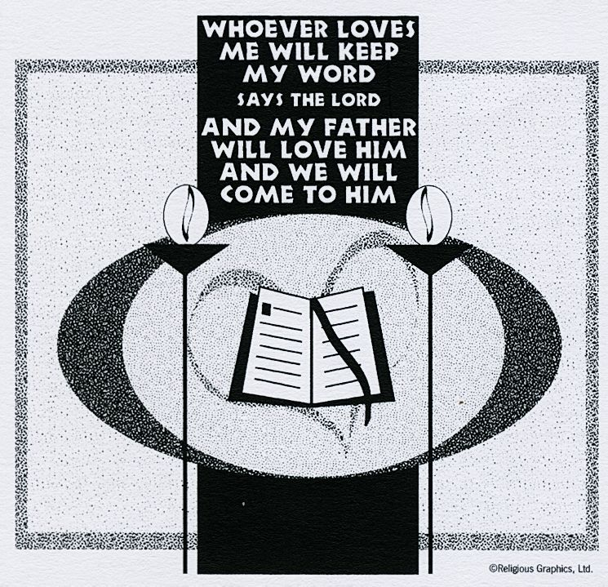
ST. ROSE CHURCH St. Rose, IIlinois
Fr. Edward F. Schaefer
18010 St. Rose Road
526-4118 Rectory

SUNDAY MASS 10:00AM
SAT. VIGIL MASS 4:00PM
WEEKDAY MASS 7:45AM
RECONCILIATION Saturday: 3:15 – 3:45PM
WEBPAGE: www.strosechurchil.com
EMAIL: belpsros@outlook.com
FACEBOOK: St. Rose Catholic Church – St. Rose, IL

MASS WILL BE LIVE STREAMED ON OUR FACEBOOK PAGE SATURDAYS AT 4PM

SUNDAY COLLECTIONS:
Weekly Envelopes: $4,082.00
Catholic Communications Fund: $11.00 Capital Improvement Fund: $1,465.00
Easter: $40.00 Seminarian Edu: $20.00 Ascension: $15.00 Sister Parish: $ 182.00
INTENTIONS: MASS
Mon 7:45AM St. Isidore No Mass
Tue 7:45AM Easter Weekday No Mass
Wed 7:45AM Easter Weekday No Mass
Thu 7:45AM St. John Maurice Timmermann
“ “ Henrietta Klostermann
“ “ Johanna Tebbe
Fri 7:45AM Easter Weekday No Mass
Sat 4:00PM Vigil Ascension of the Lord For the Parish
Sun 10:00AM Ascension of the Lord Jake Schrage
“ “ “ “ Mary Schroer
“ “ “ “ EJ, Rita & Ken Schrage

SERVERS: Sat 4PM Lexi Fuhler, Wyatt Rauen, Marissa Jansen, Everett Jansen
Sun 10AM Ruby Jansen, Wade Kramer, Briggs Kramer, Senya Rahden

READERS: Sat 4PM Brenda Niedzwiecki Sun 10AM Lisa Baer
EUCHARISTIC MINISTERS: Sat 4PM Tom Harper Sun 10AM Donna Boeing

OFFERTORY: Sat 4PM Jeana Thole, Terry Snyder, Vince Tebbe
Sun 10AM Schrage & Schroer families

VOCATION CUP: The next family to receive the Vocation Cup is the Gary Vonder Haar family.

. SYMPATHY: Our sympathy to the family of Stanley Detmer. Stanley, who passed away recently,
was the brother-in-law of Ralph (Marilyn) Bruggemann, the uncle of Duane (Julie) Bruggemann and
the great uncle of Megan & Erin Bruggemann. May Stanley enjoy the reward of eternal life.

HAVE YOU REMEMBERED ST. ROSE PARISH IN YOUR ESTATE PLANNING?

CONGRATULATIONS:
To Abbi Kampwerth who received her Associate Degree in Nursing from Kaskaskia College.
CONGRATULATIONS:
Alyssa Koerkenmeier and Lily Butler on being recognized as Mater Dei Lady Knights Basketball Championship Season Award Winners.
CONGRATULATIONS:
To the St. Rose Wildcats of the month:
Sadie Diekemper, Greta Henrichs, Addison Hilmes & Bryna Harrison
CONGRATULATIONS:
To Abigail Sturgeon & Joseph Cirrincione who were nominated to the Central High School Prom Court:
CONGRATULATIONS:
To Julie Kueper who was among 34 new members inducted into the National Honor Society at
Central High School.
CONGRATULATIONS:
To Clara Tebbe and Joseph Cirrincione who are among the thirty six seniors currently In the Central
High School National Honor Society.
CONGRATULATIONS:
To Nolan David Gray and Kyson Abraham Jacob who were Baptized here last weekend. Nolan is the son of Philip and Stephanie (Thole) Gray and Kyson is the son of Kyle and Evonne (Huelsmann) Jacob.
Many blessings to them!

HAPPY ANNIVERSARY:
May 15 Brian & Alison Schumacher ’18 May 15 David & Mary Veizer ‘04
May 16 Nick & Michelle Tebbe ’98 May 17 David & Connie Tebbe ‘86
May 17 Nathan & Karla Tebbe ’03 May 20 Dave & Rebecca Boeschen ‘00
May 20 Scott & Gina Kuhn ’94 May 21 Matthew D. & Lora Benhoff ‘88
HAPPY BIRTHDAY:
May 15 Bernie Goebel May 18 Kaitlyn Holtgrave May 19 Alivia Wilke 6
May 15 Karl Kampwerth May 18 Stanley Holtgrave May 20 Bernell Wellen
May 16 Rita Thole May 18 Ethan Segert 20 May 21 Lily Butler 15
May 16 Jeana Thole May 18 Andrew Straeter May 21 Alyson Scott 13
May 16 Chelsie Wiegmann May 18 Lexis Wiegmann May 21 Rebecca Sturgeon
May 17 Joseph Dulle May 19 Dale Huelsmann
May 17 Brent Timmermann May 18 Nathan Schrage

VOCATIONS:
Mothers’ Day – what a wonderful commemoration of one of the greatest vocations there is.
We are inspired by the example of Mary, the Mother of God, to live by the words from the
Cana feast “Do whatever He tells you”. We pray for all our Mothers today and for the
families they form, nurture and love. We also ponder our own “FIAT” – our surrendering to
God’s plan for us.
BABY BOTTLE BOOMERANG!
Relevant Pregnancy Options Center in Highland is once again sponsoring their Baby Bottle
Fund Campaign. Baby bottles are located inside church. Please stop and pick one up and donate
what you can to this worthy cause. Bottles are to be returned on Sunday, June 18th.
CSMA:
As of April 29th St. Rose exceeded their CSMA goal. Thank you to all who contributed!

“HAPPY MOTHERS DAY!”

