St. Felicitas Church
PRAYER REQUEST
Please pray for those who need the Lord healing in body, mind or spirit, especially Florence Huelsmann, Margie McQuade, Taylor Marti, Gerald Hilmes, Ken Wellen, Jim Jansen,
Jerome Jansen, Ed McQuade
and all who asked for our prayers.
Fr. Dale Maxfield, and all who asked for our prayers.

13322 Church Road
Carlyle, IL 62231
Phone: 594-3040 Fax: 594-3040
stfelbp@wisperhome.com

Father Ed Schaefer
belpsros@outlook.com
Cell: 618-526-4118

Father Tom Killeen

Parish Pastoral Council: Justin Benhoff, Gene Bickl, Cindy Gnaedinger, Joe Luebbers
Finance Council: Mary Huelsmann, John Ketterer, Dan Potthast, Allen Thole and Margie McQuade.
Parish Trustees: Barry Hampel and Alan Heldorfer
Administrative Asst: Deb Rakers 618-698-9141 or 618-594-3040

Thirty-first Sunday in Ordinary Time
Tomorrow we celebrate the solemnity of All Saints, when we recognize those many men and women who we believe have gained the eternal reward and are forever in the presence of God. Today we hear Jesus tell a scribe, “You are not far from the kingdom of God,” suggesting that this anonymous functionary was close to being a saint. To be a saint should be our goal, so let us listen to the Gospel and pray that we take Jesus’ words to heart and put them into action.
Moses knew the power of God since it flowed through him flowing with milk and honey. Therefore, he enthusiastically exhorted his people to love God with all their hearts, soul, and strength. Jesus repeats this directive in the Gospel, adding its complement: love your neighbor as yourself. Let us embrace these commandments as the foundation of our life.

Question of the week
Do I think Jesus would tell me that I am “not far from the kingdom of God?” What should I do to become closer.?

The 2021 Catholic Service and Ministry Appeal (Whoever believes in me will do the work that I do…John 14:12)
YOUR GIFT to The CSMA helps Catholic 88Urban Programs provide food, clothing, shelter, and assistance of every kind to people who lack the basic necessities of life to survive. Your gift to The Appeal will enable Catholic Urban to continue their important work.

WEEKLY OFFERING
10-24-2021
Number of Envelopes 28
Envelopes Total $989.00
Loose Collection $63.00
Grand Total. $1052.00
World Mission Sunday………….$75.00
Chicken Dinner …………...$10,756.37
(awesome)

Our monthly income for September 2021 was $3540.00 our monthly expenses totaled $10,402.00. Please give as you are able.
(assessments paid to the Diocese and ASA school)

Thank you for your generosity!

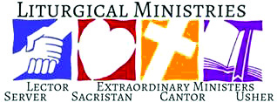

October 31: 9:30 am
LECTORS: Millie Peppenhorst
MINISTERS OF HOLY COMMUNION: Lisa Voss
GIFT BEARERS: volunteers
SERVERS: PSR class
MUSICIAN: Lisa Mcquade

November 7: 9:30
LECTORS: Sharon Bickl
MINISTERS OF HOLY COMMUNION: Ann Hampel
GIFT BEARERS: Virginia & Jim Jansen
SERVERS: PSR Class
MUSICIAN: Chad Schrage

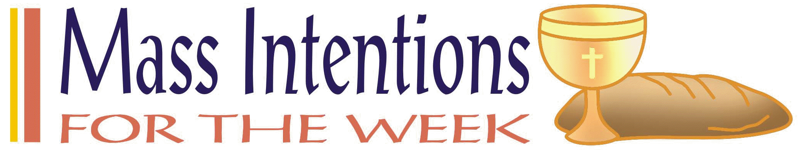

October 31: deceased members of our parish

November 7: Herman & Reginia Jansen

Abigail Voss – November 2
Lora Weiss – November 4
Aaron & Kelli Hilmes – November 2 – 8 years
Daniel & Sue Potthast – November 4 – 26 years
Travis & Jaclyn Albers – November 6 – 11 years

If you would like to be recognized for your birthday or anniversary in the weekly bulletin, please mark your special day in the calendar in the back of church
____________________________

VOCATION CORNERS
Oct. 31st – “National Vocation Awareness Week, celebrated November 7-13, 2021, is an annual week-long celebration of Catholic Church in United States dedicated to promote vocations to the priesthood, diaconate and consecrated life through prayer and education, and to renew our prayers and support for those who are considering one of these particular vocations.”
United States Council of Catholic Bishops website.

National Shrine of Our Lady of the Snows Way of Lights need volunteers from Friday, November 19 – Friday, December 31, 2021.
Looking for a special way to share the holiday spirit? Volunteer for a shift or two during the Way of Lights greeting visitors to the Christmas tree display or helping at the Oblates Exhibit area at the Shrine of Our Lady of the Snows from November 19th thru December 31. This is also a great opportunity for youth service hours. If interested, please email programs@snows.org or call 618-394-6281 snows,org/wol
Nov. 7 - Drive thru Fall Chicken Dinner
Serving 11:00 a.m. to 6:00 p.m.
St. Cecilia Parish Center, Bartelso, IL
Enter by the bowling alley on 161 then follow behind church/school, and carry outs will be handed out the south side of the school and exit on S. Washington St. There will be signs posted. Featuring: ½ Chicken, mashed potatoes, gravy, homemade dressing, green beans, slaw and cake. $11.00, sponsored by Ladies Sodality.
Nov. 10 – Diocesan Fall Blessing of the Harvest at 1 p.m. Mike Chwasczinski Family Farm, Ashley, IL
Directions and additional information is on the bulletin board.

St. Dominic’s Rummage Sale dates:
Sunday, Oct. 31 – 9 a.m. thru 3 p.m. ($3.00 brown bag sale or $5.00 for 2 bags.)
A carry-out lunch will be provided.
____________________________________________
CONGRATULATIONS TO OUR PARISH CHILDREN WHO MADE THE HONOR OR HIGH HONOR ROLL.
They are:

Dist. 12 High Honor Roll – Chase Luebbers
Honor Roll – Justin Hilmes
Conner Carrillon
Maecie Carrillon
Alex Voss

Central H.S. High Honor Roll – Cara Carrillon
Honor Roll – Abby Vloss
Madyson Diekemper
Makenzie Diekemper

Mater Dei -High Honor Roll- Alayna Benhoff

All Saints - High Honor Roll-Mariah Benhoff
Makenna Benhoff

The annual Blessing of the Harvest will be held on Wednesday, 11-10-21 at 1 p.m. at the Mike Chwasczinski Family Farm, 5211 Indian Trail Road in Ashley, IL Additional information on bulletin board.

BCMW requested us to participate in their Adopt-A-Family Program this year. Three ways we can participate is:
- Buy and wrap gifts for selected families and deliver them to BCMW by 12-2-2021.
- Make a financial donation for a family, and volunteer shoppers will purchase gifts.
- Donate new toys

And a suggestion was made to donation to another family from the Lady Sodality.

This Photo by Unknown Author is licensed under CC BY-NC-ND

Please Update your contact information
Are your records current? Have you dropped your landline or changed your cell number? Have you moved, been married, divorced or had a baby? Please help us keep our records accurate. Please check the folder on the back table and let us know at the parish office by emailing: stfelbp@wisperhome.com. or drop an envelope in the collection basket with your correct information

- With whom will I stand in faith?
- How will I keep my eyes fixed on Jesus this day?
Fliers for the upcoming chicken dinner, which is, are available in the back of church.
Please take some and help spread the word.
Worklist and raffle tickets are also available,
please pick up your copy to help save with postage cost.
Also, please start saving your empty ice cream,
margarine, etc containers to use for leftover food.

Please pray for those who need the Lord’s healing in body, mind or spirit, especially Florence Huelsmann, Margie McQuade, Ramona Haislar, Taylor Marti, Gerald Hilmes, Ken Wellen,, Jim Jansen

Please Update your contact information
Are your records current? Have you dropped your landline or changed your cell number? Have you moved, been married, divorced or had a baby? Please help us keep our records accurate. Please check the folder on the back table and let us know at the parish office by emailing: stfelicitasbeaverprairie@gmail.com.

Please Update your contact information
Are your records current? Have you dropped your landline or changed your cell number? Have you moved, been married, divorced or had a baby? Please help us keep our records accurate. Please check the folder on the back table and let us know at the parish office by emailing: stfelbp@wisperhome.com. or drop an envelope in the collection basket with your correct information.

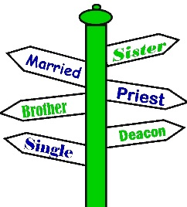

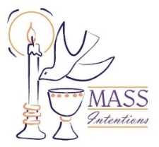
We welcome request for Mass Intentions
You can remember someone who has died recently or many years ago. But the intentions do not have to be just for the dead. They make beautiful gifts for any special occasion: birthdays, anniversaries, or even in thanksgiving. Mass intentions can be made by contacting the parish office or you may drop the following form along with payment in an envelope mark “Mass Intention” in the collection basket. Intentions are $10 per mass.
Available upcoming dates: Sept. 29; Oct. 6, 13 & 27

For: ___________________________________
Date requested: __________________________
Requested by: ___________________________
Phone Number: __________________________
If you have something you would like posted in the bulletin, please have it to the church office by Wednesday evening
via email to: stfelbp@wisperhome.com
or test Lisa by noon on Thursday

.

FATHER BRETT

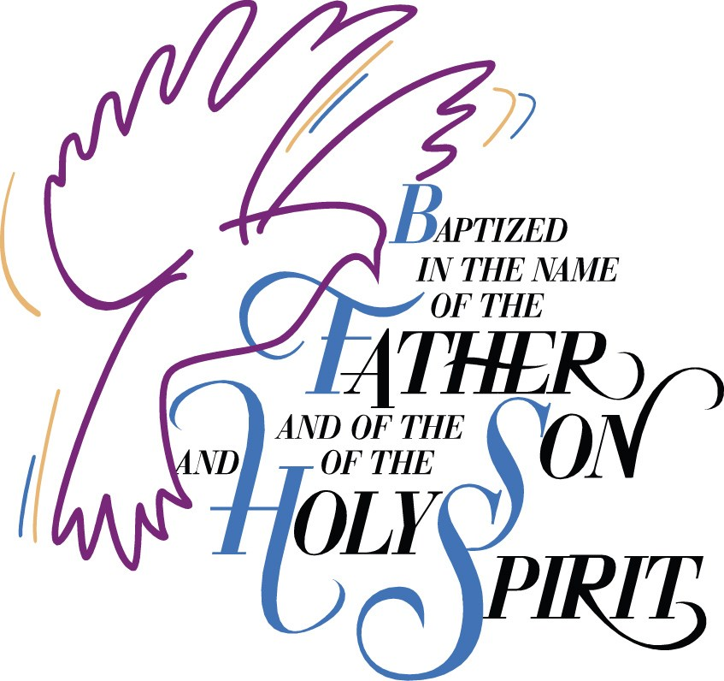

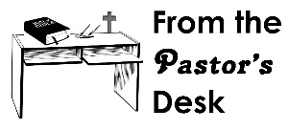

September 5: 9:30am
LECTORS: Millie Peppenhorst
MINISTERS OF HOLY COMMUNION: Lisa Voss
GIFT BEARERS: Monken’s family
SERVERS: Abby, Alex, Alayna, Mariah & Makenna
MUSICIAN: Lisa McQuade

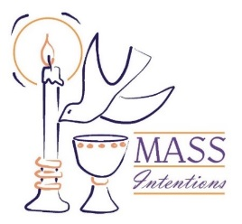
We welcome request for Mass Intentions
You can remember someone who has died recently or many years ago. But the intentions do not have to be just for the dead. They make beautiful gifts for any special occasion: birthdays, anniversaries, or even in thanksgiving. Mass intentions can be made by contacting the parish office or you may drop the following form along with payment in an envelope mark “Mass Intention” in the collection basket. Intentions are $10 per mass.

For: ___________________________________
Date requested: __________________________
Requested by: ___________________________
Phone Number: __________________________

