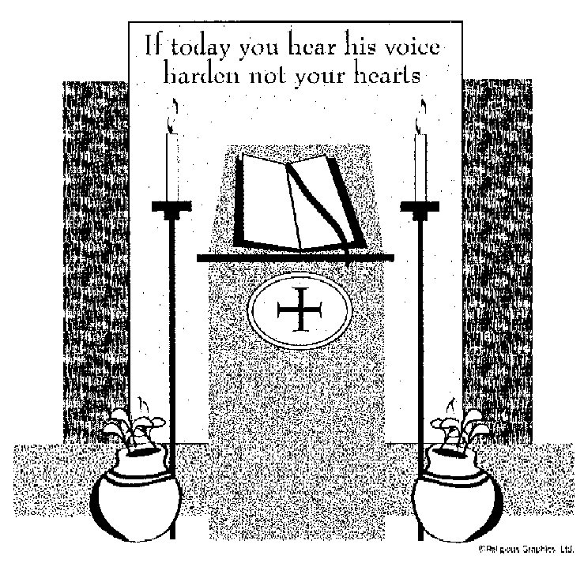

ST. ROSE CHURCH
ST. ROSE , IIlinois
Fr. Edward F. Schaefer
18010 St. Rose Road
526-4118 Rectory

SUNDAY MASS 10:00AM
SAT. VIGIL MASS 4:00PM
WEEKDAY MASS 7:45AM
RECONCILIATION Saturday: 3:15 – 3:45PM

WEBPAGE:: www.strosechurchil.com
EMAIL: belpsros@outlook.co
FACEBOOK: St. Rose Catholic Church – St. Rose, IL

MASS WILL BE LIVE STREAMED ON OUR FACEBOOK PAGE SATURDAYS AT 4PM

SUNDAY COLLECTIONS: Weekly Envelopes: $2,379.00
Sister Parish: $ 45.00
Capital Improvement Fund: $ 290.00
MASS INTENTIONS: MASS
Mon 7:45AM Weekday NO MASS
Tue 7:45AM Weekday NO MASS
Wed 7:45AM St. John Bosco Rev. Carl Pimeskern
Thu 7:45AM Weekday NO MASS
Fri 7:45AM Presentation of the Lord Catholic Extension Donor Intention
Sat 4:00PM VIGIL: Fifth Sunday in Ordinary Time L/D Erwin & Evelyn Kohlbrecher Family “ “ “ “ L/D Leo & Regina Tebbe Family
“ “ “ “ JoAnn Vonder Haar
Sun 10:00AM Fifth Sunday in Ordinary Time For the Parish

SERVERS: Sat . 4PM Kayley Burian, Rylee Alberternst, Raegen Alberternst, Gavin Schneider
Sun 10AM Addison Thole, Aubrey Thole, Senya Rahden, Ava Sidwell

READERS: Sat 4PM Brenda Niedzwiecki Sun 10AM Pam Andrews
EUCHARISTIC MINISTERS: Sat 4PM Deb Wessel Sun 10AM Donna Boeing & Marilyn Fuhler
OFFERTORY: Sat 4PM Kohlbrecher, Tebbe & Vonder Haar Families
Sun 10AM Gary Tebbe, Paul Thole & Nick Timmermann, Jr.

VOCATION CUP: The next family to receive the Vocation Cup is the Jason Bange family.
PLEASE WELCOME: Deacon Linus Klostermann who is helping with the Masses this weekend.

UPDATE ON ST. JUSTINA:
We have received a letter from Sr. Justina updating us on her current situation. Please see bulletin board. Her address is 726 Community Dr., Dammert Nursing Center, Belleville IL 62223
SYMPATHY: Our sympathy to the family of Victor “Vic” Fuhler who passed away recently.
“Vic” was the Brother-In-Law of Jane Fuhler. May “Vic” enjoy the reward of eternal life.

SYMPATHY: Our sympathy to the family of Jerome “Klank” Rakers. Jerome, who passed away
recently, was the Brother-In-Law of Joe Heinzmann. May “Klank” enjoy the reward of eternal life.
ANNIVERSARY: Feb 2 John & Jan Kalmer ’74 Feb 4 Dan & Cheryl Koerkenmeier ‘95
CONGRATULATIONS: To John & Jan Kalmer who are celebrating 50 years of marriage.
HAPPY BIRTHDAY:
Jan 29 Carrie Kramer Jan 31 Patricia Wellen Feb 02 Andrew Tebbe
Jan 29 Deborah Wilke Feb 01 Dave Kueper Feb 03 Justin Dulle
Jan 30 Marilyn Bruggemann Feb 01 Lorene Rehkemper Feb 03 Macy Tebbe 9
Jan 30 Wesley Buehne Feb 01 Marilyn Schorfheide Feb 03 Doris Timmermann
Jan 30 Ronald Holtgrave Feb 02 Lainey Clugston 5 Feb 04 Betty Eilers
Jan 30 Vincent Tebbe Feb 02 Brady Jansen 10 Feb 04 Michael Harper
Jan 30 Edward Wilke Feb 02 Sherry Rehkemper Feb 04 Greg Rehkemper
Jan 31 Omar Rojas, Jr. 16 Feb 02 Brandy Schwierjohn
Vocations: “Though I was raised in a Catholic family and blessed with good priests
throughout my life, the priesthood did not attract me when I was young. In fact, during college, I didn’t even practice the faith. The Lord eventually led me back to the Church, and when he began to call me to the priesthood, I was both terrified and excited. He was asking me to sacrifice my will and to trust and follow him. This meant breaking up with the girl I was dating and placing my desires for fatherhood and family into his hands. Had I been called when I was younger, I wouldn’t have been mature enough in my faith to answer with the generosity and trust that let me to the priesthood.”
Father Jonathan Schnobrich, Diocese of Burlington, Vt.
DIOCESE OF BELLEVILLE HOSTING PERMANENT DIACONATE INFORMATIONAL MEETING:
Saturday, Feb 3rd at 10AM. See bulletin board for more information.
2024 PARISH DIRECTORY: Only February dates remain: Fri., Feb 16 & Sat Feb 17.
Register on line: STEP 1: www.ucdir.com STEP 2: Click/Tap on Photography Appointment Scheduling STEP 3 Church Code: il348 Password: photos STEP 4 Click on date. STEP 5 Click on time: STEP 6 Enter information. Any questions, please call Jeff/Amy Kampwerth at 618-406-6908.
SUBMITTED PHOTOS: Look for instructions in next week’s bulletin.
CATHOLIC FRATERNAL LIFE EUCHRE TOURNAMENT: Sun., Feb 11th at 1PM
In the Development Club. Proceeds benefit Community Christmas Lighting Fund.
ST. DAMIAN CHURCH DAMIANSVILLE MEXICAN FISH FRY:
Friday, Feb 9th 4:30PM to 7:30PM in the Damiansville Gym. Mariachi Band 5-7PM
YOUTH SING PRAISE (YSP) PERFORMING ARTS YOUTH RETREAT:
A unique musical theatre & retreat camp for teens. In just 8 days & nights, students audition, learn & perform a faith-based musical like Godspell. This year’s performance takes place June 29 at Immaculate Conception Church in Columbia. Application and instructions at www.youthsingpraise.com
HIGHLAND MEALS ON WHEELS: Provides hot nutritious noon meals prepared by St. Joseph’s Hospital dietary department to qualified residents of Highland, Marine, St. Jacob, Grantfork, Pierron, St. Rose, Pocahontas & New Douglas, Monday through Friday including all major holidays. If you or someone you know might need their services or if you would like to volunteer contact Meals on Wheels at 618-954-0356. Donations also accepted at 12603 State Rte 143, G-303, Highland IL 62249
“BEAUTIFUL EUCHARIST!” You know the book you received on Christmas Day. It contains 13 personal reflections by thirteen very special people on Jesus in the Holy Eucharist. How many have you read so far? Which one helped you see the Holy Euchrist in a new way? Email your thoughts to
myrtrollins@gmail.com. You’re Adult Faith Formation Team would really like to know.

HAVE YOU REMEMBERED ST. ROSE PARISH IN YOUR ESTATE PLANNING?

