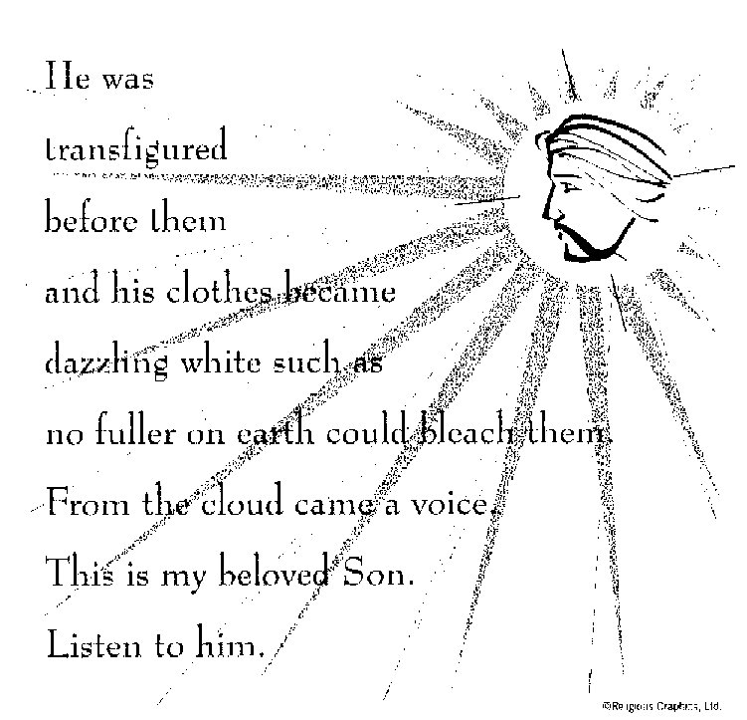

ST. ROSE CHURCH
ST. ROSE, IIlinois
Fr. Edward F. Schaefer
18010 St. Rose Road
526-4118 Rectory

SUNDAY MASS 10:00AM
SAT. VIGIL MASS 4:00PM
WEEKDAY MASS 7:45AM
RECONCILIATION Saturday: 3:15 – 3:45PM

WEBPAGE:: www.strosechurchil.com
EMAIL: belpsros@outlook.com
FACEBOOK: St. Rose Catholic Church – St. Rose, IL

MASS WILL BE LIVE STREAMED ON OUR FACEBOOK PAGE SATURDAYS AT 4PM

SUNDAY COLLECTIONS: Weekly Envelopes: $2,437.00
Sister Parish: $ 30.00
Black & Indian: $88.00 Capital Improvement Fund: $ 655.00
MASS INTENTIONS: MASS
Mon 7:45AM Lenten Weekday NO MASS
Tue 7:45AM St. Gregory of Narek NO MASS
Wed 7:45AM Lenten Weekday Rev. Dennis Voss
Wed 7:00PM Rev. John Quack
Thu 7:45AM Lenten Weekday NO MASS
Fri 7:45AM Lenten Weekday Jeanette Benhoff
Sat 4:00PM VIGIL: Third Sunday of Lent For the Parish
Sun 10:00AM Third Sunday of Lent Rev. Joseph Pingsterhaus
“ “ “ Jim Fuhler
“ “ “ Gervase “Gerp” Buehne
SERVERS:
Sat 4PM Alaina Schrage, Ava Tisher, Lexi Fuhler, Sam Fuhler
Sun 10AM Caitlyn Vonder Haar, Lauryn Vonder Haar, Lydia Thole, Cole Timmermann
Wed 7:00PM Noah Schuette, Grayce Sturgeon, Jacob Sturgeon, Nick Sturgeon

READERS: Sat 4PM Jeff Kampwerth Sun 10AM Lisa Baer
EUCHARISTIC MINISTERS: Sat 4PM Jean Tebbe Sun 10AM Amanda Rauen & Melanie Rund
OFFERTORY: Sat 4PM Ralph Goebel, John Hustedde, Karl Klostermann
Sun 10AM Fuhler & Buehne Families

VOCATION CUP: The next family to receive the Vocation Cup is the Regan Bassick Family.
PLEASE WELCOME: Deacon Linus Klostermann who is helping with the Masses this weekend.

MATER DEI: Tues., Feb 26th Father & Friends Meeting 7PM

“HAVE YOU REMEMBERED ST. ROSE PARISH IN YOUR ESTATE PLANNING?”

ANNIVERSARY: Feb 26 Trevor & Sierra Koerkenmeier ’22 Feb 26 Bill & Amanda Rauen ‘11
Feb 29 Thomas & Kathleen Altgilbers ’60 Mar 03 Nathan & Emioly Gall ‘18
HAPPY BIRTHDAY:
Feb 27 Colby Detmer 17 Feb 28 Leona Thole Mar 02 Elizabeth Scott 18
Feb 27 Lydia Thole 14 Mar 01 Debbie Fuhler Mar 02 Lisa Smith
Feb 27 Chad Vonder Haar Mar 01 Tammy Kampwerth Mar 02 Dan Tebbe
Feb 28 Diana Dulle Mar 01 Jim Richter Mar 03 Jason Bange
Feb 28 Emma Heinzmann 5 Mar 02 Lillian Henrichs 16 Mar 03 Rylan Schneider 9
Feb 28 Kathleen Klostermann Mar 02 Marissa Jansen 14 Mar 03 Jennifer Schrage
Feb 28 James Kuper 12 Mar 02 Marilyn Rehkemper
Feb 28 Blake Monken 17 Mar 02 Lauren Schumacher
LENTEN RECONCILIATION SERVICES:
Mar 4 6-7PM St. Mary Centralia Mar 5 St. Rose 7PM
Mar 7 St. Mary Centralia School 12:30 – 2PM Mar 10 St. Bernard Albers 1PM
Mar 10 St. Mary Carlyle 3PM Mar 10 St. Cecilia Bartelso 6PM
Mar 13 St. Mary Trenton 7PM Mar 14 St. Dominic Breese 7PM
Mar 15 St. Mary Mt. Vernon 6-9PM Mar 17 St. Francis Aviston 3PM
VOCATIONS: “People often discover their vocation to religious life at Mass or in adoration, but I “heard the call” while literally receiving a phone call! Before this life-changing moment during my last semester of college, I had spent about a year growing in my spiritual life through spiritual direction and getting to know members of Pro Ecclesia Santa. I was attracted to their joy, their charism to live and promote holiness, and their closeness to the Sacred Heart. But I was wrestling with the question of whether God was really calling me to religious life. Speaking on the phone with a potential roommate for the following year, I knew deep down that I was fooling myself. I didn’t need to make housing plans; God wanted me to say “yes” to my vocation and move in with the sisters. Whatever your state of life, say ‘yes’ to God’s will and let yourself be surprised by his loving plans for you. “. Sister Leann Luecke; Pro Ecclesia Santa
A SEASON FOR REFLECTION: OVERCOMING HUNGER: In Akwangagwel, Uganda, the climate is very hot and dry. Farmers in this region depend heavily on the rainy season for a successful harvest. But lately – due to the changing climate – the rain has been coming later than it used to and is more inconsistent. Sometimes, when it does rain, it causes flooding and ruins the crops. Learn how Adolf & Florence have teken the matter into their own hands, implementing new farming techniques they learned from a Catholic Relief Services program. Visit crsricebowl.org to read this week’s Story of Hope.
ST. ROSE DIRECTORY: FINAL notice for SUBMITTED PHOTOS: Please contact Melisa Hemann at
618-210-4887 (Deadline for Submitted Photos = Feb 26), Any other questions, please call Jeff/Amy
Kampwerth 618-406-6908.
ST. ROSE CEMETERY CLEAN UP:St. Rose Cemetery will be cleaned March 16-23. All Christmas, deteriorated, and broken decorations will be removed. If you wish to save any of these items, please remove them before March 16th. Please remove grave blankets soon to avoid killing the grass.
SRDC FISH FRY: Friday, Feb 23 at the Park from 4PM to 7PM
BREESE AMERICAN LEGION CHICKEN DINNER: this Sun., Feb 25th 11AM – 5PM
Carry outs or drive through only. All dinners $15
HSHS ST. JOSEPH BREESE ANNUAL USED BOOK FAIR AND BAKE SALE:
February 29 – March 2 at the Breese KC Hall. See bulletin board for more information or call
618-526-5351 or Christine.gebke@hshs.org.
SRDC EUCHRE TOURNAMENT: This Sunday, Feb 25th 7PM in the Development Club.
VILLAGE MEETING: Wed., Feb 28th 7:30PM
ST. ROSE SENIOR CITIZEN EUCHRE TOURNAMENT: Wed., Feb 28th 1PM in SRDC
IMMACULATE CONCEPTION PIERRON DRIVE-THROUGH CHICKEN DINNER:
Sunday, Mar 3 from 11AM to 5PM. All dinners $15.
BREESE LIONS CLUB ANNUALCHICKEN DINNER: Sun., Mar 3rd Serving 11AM to 6PM
Adults Advance tickets $13 and $15 at the door. Carry Outs Only.

