ST. ROSE CHURCH St. Rose, IIlinois
Fr. Edward F. Schaefer
18010 St. Rose Road
526-4118 Rectory

SUNDAY MASS 10:00AM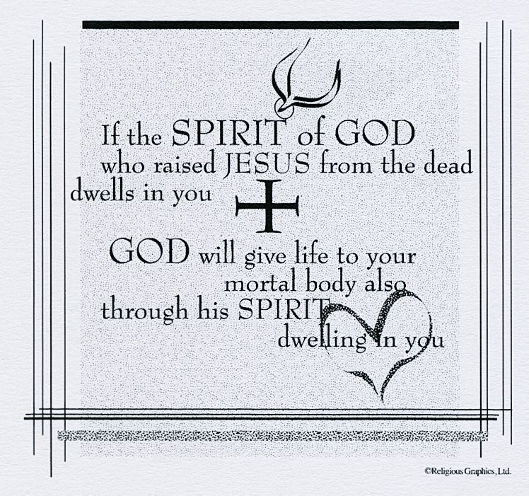
SAT. VIGIL MASS 4:00PM
WEEKDAY MASS 7:45AM
RECONCILIATION Saturday: 3:15 – 3:45PM
WEBPAGE: www.strosechurchil.com
EMAIL: belpsros@outlook.com
FACEBOOK: St. Rose Catholic Church – St. Rose, IL

MASS WILL BE LIVE STREAMED ON OUR FACEBOOK PAGE SATURDAYS AT 4PM

SUNDAY COLLECTIONS: Weekly Envelopes: $3,180.00
Catholic Relief Service: $369.00 Capital Improvement Fund: $ 660.00
Sister Parish: $ 55.00

INTENTIONS: MASS
Mon 7:45AM Lenten Weekday No Mass
Tue 7:45AM Lenten Weekday No Mass
Wed 7:45AM Lenten Weekday No Mass
Thu 7:45AM Lenten Weekday No Mass
Fri 7:45AM Lenten Weekday No Mass
Sat 4:00AM Vigil Palm Sunday L/D Ted & Mary Ann Tebbe Family
“ “ “ Freemont & Rose Gnaedinger
“ “ “ Anna Mae Frisse
Sun 10:00AM Palm Sunday For the Parish

SERVERS: Sat 4PM: Gavin Schneider, Tinsley Schwierjohn, Kayley Burian, Lexi Fuhler
Palm Sun 10AM: Ava Hilmes, Bryna Harrison, Danica Henrichs, Addison Hilmes
READERS: Sat 4PM: Brenda Niedzwiecki & Myrt Rollis
Palm Sun 10AM: Pam Andrews & Terry Kampwerth
EUCHARISTIC MINISTERS: Sat 4PM Ed Schrage Palm Sun 10AM: Deb Wilke
OFFERTORY:Sat 4PM: Tebbe, Gnaedinger & Frisse Families
Palm Sun 10AM: Gary Vonder Haar, Stan Essenpreis, Cory Schneider

VOCATION CUP: The next family to receive the Vocation Cup is the Daniel Trame Family.
WELCOME: Please welcome Monsignor John Myler who will be having the Saturday 4PM Mass and
Fr. Mike Powell who will be having the Sunday 10AM Mass this weekend.

SYMPATHY: Our sympathy to the family of Judith Ann “Judy” Thurston. Judy who passed away
recently, was the mother of Julie (Duane) Bruggemann and the grandmother of Megan (special friend Andrew Hagen) and Erin Bruggemann. May Judy enjoy the reward of eternal life.

“HAVE YOU REMEMBERED ST. ROSE PARISH IN YOUR ESTATE PLANNING?”

PSR CRAFT & BAKE SALE
THIS WEEKEND IN THE CAFETERIA
AFTER THE 4PM AND 10AM MASSES

THANK YOU: Thank you to the Breese Knights of Columbus for their generous donation
of $375.00 to the PSR Program.
CONGRATULATIONS: To the following Mater Dei Honor Roll students for the Third Quarter:
Nadia Baer, Alexis Kampwerth, Alyssa Koerkenmeier, William Meyer, Avery Rahden, Elizabeth Scott,
Lily Butler, Lily Ann Goebel, Cora Meyer & Aftyn VonderHaar.
HAPPY ANNIVERSARY: Mar 29 Ronald & Bonnie Wilke ’80 Mar 31 Matthew & Lisa Schrage ‘89
HAPPY BIRTHDAY:
Mar 27 Lexi Alberternst 10 Mar 29 Rylee Jo Alberternst 13 Mar 30 Karen Tebbe
Mar 27 Brooks Buehne 2 Mar 29 Jeffrey Buehne Mar 31 Dale Richter
Mar 27 Pat Henrichs Mar 29 Susan Goestenkors Mar 31 Henry Tebbe
Mar 27 Joyce Korte Mar 29 Lance Rahden Mar 31 David Thole
Mar 27 Layney Tebbe 15 Mar 29 Brooke Remmert Apr 01 Jan Tebbe
Mar 28 Jack Bassick 2 Mar 29 Danny Schumacher Apr 01 Clara Tebbe
Mar 28 Pearl Rosen Mar 29 Kyle Thole Apr 02 Richard Kohlbrecher
Mar 26 Colin Vonder Haar 15 Mar 30 Reed Segert
VOCATIONS: “I grew up in Haiti as the first child in a family of cradle Catholics. I heard stories about how my dad discerned the priesthood before he married my mom, and I witnessed the humanity of the religious sisters who taught me in school. This faith-filled environment sowed the seeds of my religious vocations, and as a young girl I believed I was called to be a sister. Years later, after my family settled in the United States, I became a lost sheep on a college campus. In 2008, I began to go to daily Mass, participated in Eucharistic adoration, and found a spiritual director. My discernment journey took me to many communities until, in 2010, I knew that the Lord was asking me say “yes” to him through the Sisters of Mary, Mother of the Church.” Sister Christiana Marie Rene; Sisters of Mary, Spokane Wash.
ST. ROSE WEDNESDAY LENTON HOLY HOUR:
Our last St. Rose Holy Hour with Adoration of the Blessed Sacrament & Reflections on the Eucharist
will include Prayers for the Church’s Missionaries & our Mission to bring Christ & His love to our
world! Come join us in church at 7PM THIS WEDNESDAY, March 29th in the Presence of our Lord.
THE POWER OF SACRIFICE:
This lent we’ve learned how people in Honduras, the Phillipines & Kenya made sacrifices so their
families and communities can thrive. How have your Lenten sacrifices helped your family and
community and communities around the world? Visit crsricebowl.org to learn more
HOLY MOMENTS’ BOOK:
Have you read your “Holy Moments’ Book? And have you created a Holy Moment (Doing anything that God would like you to do)? How about trying to make a One Holy Moment a Day??
LENTEN RECONCILIATION:
St. Francis, Aviston Sunday, March 26th 3PM St. Lawrence, Sandoval Sunday, March 26th 2PM St. Mary, Carlyle March 26th 3PM
SPRING CONCERT:
Heartland Community Chorus invites you to their concert, “A Celtic Celebration”:
THIS Saturday, Mar. 25th at 7:30PM & Sunday, Mar. 26th at 3PM at St. Paul Church, Highland.
Tickets available from chorus members & at hearlandcommunitychorus.org
ST. DAMIAN, DAMIANSVILLE HOLY NAME ANNUAL WURSTMARKT:
THIS Sunday, March 26th in the Parish Gym from 10:30AM to 5:30PM.

