ST. ROSE CHURCH St. Rose, IIlinois
Fr. Edward F. Schaefer
18010 St. Rose Road
526-4118 Rectory

SUNDAY MASS 10:00AM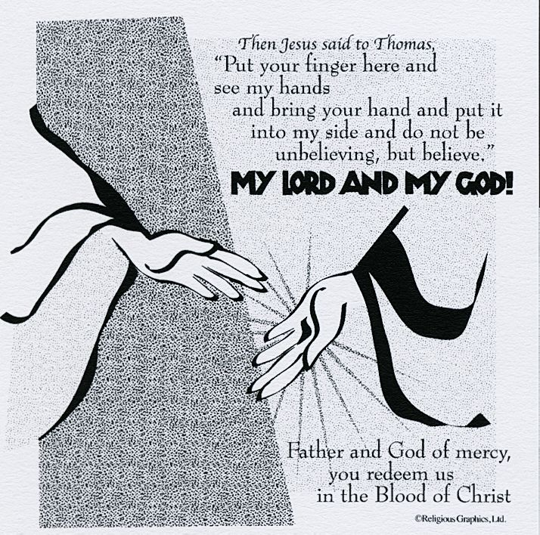
SAT. VIGIL MASS 4:00PM
WEEKDAY MASS 7:45AM
RECONCILIATION Saturday: 3:15 – 3:45PM
WEBPAGE: www.strosechurchil.com
EMAIL: belpsros@outlook.com
FACEBOOK: St. Rose Catholic Church – St. Rose, IL

MASS WILL BE LIVE STREAMED ON OUR FACEBOOK PAGE SATURDAYS AT 4PM

SUNDAY COLLECTIONS:
Weekly Envelopes: $1,615.00
Holy Thursday $376.00 Easter $6,463.00 Capital Improvement Fund: $ 955.00
Catholic Communication: $20 Seminarian Edu: $30.00 Sister Parish: $ 171.00
Ascension $30.00 Catholic Relief: $10.00 Donation: $5,000.00

INTENTIONS: MASS
Mon 7:45AM Easter Weekday No Mass
Tue 7:45AM Easter Weekday No Mass
Wed 7:45AM Easter Weekday No Mass
Thu 7:45AM Easter Weekday No Mass
Fri 7:45AM Easter Weekday No Mass
Sat 4:00PM Vigil Third Sunday of Easter For the Parish
Sun 10:00AM Third Sunday of Easter JoAnn Vonder Haar
“ “ “ Karl Schrage
“ “ “ Gervase Buehne

SERVERS: Sat 4PM Ali Butler, Marissa Jansen, Danica Henrichs, Noah Schuette
Sun 10AM Ava Hilmes, Wade & Briggs Kramer, Lauryn Vonder Haar

READERS: Sat 4PM First Communicants Sun 10AM Myrt Rollins

EUCHARISTIC MINISTERS: Sat 4PM Marilyn Fuhler Sun 10AM Ruth Holtgrave

OFFERTORY: Sat 4PM First Communicants
Sun 10AM Vonder Haar, Schrage & Buehne Families

VOCATION CUP: The next family to receive the Vocation Cup is the Chad Vonder Haar family.

HAVE YOU REMEMBERED ST. ROSE PARISH IN YOUR ESTATE PLANNING?

SYMPATHY: Our sympathy to the family of Marilyn Jansen. Marilyn, who passed away recently,
Was the mother of Debra (Rich) Knebel and the grandmother of Adam (Julie) Knebel,
Alex (Kelly) Knebel and Anna (friend, Gage Kickle) Knebel. May Marilyn enjoy the reward of
Eternal life.
CONGRATULATIONS: To Anna Marie Mueller who received her Confirmation last weekend.
Many Blessings to her!
CONGRATULATIONS: To Seth Lane, James Kuper, Lucinda Kuper, Emma Mueller and
Adelina Klostermann who were Baptized here last weekend. Seth is the son of Alexander
Hickey and Anna Marie (Lane) Mueller. James and Lucinda are the children of Benjamin Kuper and Erika (Montes) Kuper. Emma is the daughter of Shanon Mueller and Anna Marie (Lane) Mueller and
Adelina is the daughter of Kyle Klostermann and Erika (Montes) Kuper. Many Blessings to them!

HAPPY ANNIVERSARY:
Apr 18 Eric & Beverly Faust ’00 Apr 19 Martin & Karen Schumacher ’85
Apr 21 Adam & Julie Knebel ’18 Apr 21 Scott & Kristie Tebbe ‘01
HAPPY BIRTHDAY:
Apr 14 Fr. Ed (Happy belated)
Apr 17 Cade Breed Apr 20 Alan Carrillon Apr 22 Mary Wellen
Apr 17 Brooke Buehne Apr 20 Debra Smith Apr 23 Timothy Droege
Apr 17 Robert Ottensmeier Apr 21 David Niedzwiecki Apr 23 Tyler Kramer
Apr 18 Daniel Benhoff Apr 22 Melissa Rehkemper Apr 23 Albert Tebbe
Apr 19 Adam Niedzwiecki Apr 22 Karen Schumacher

VOCATIONS:
Today’s readings offer so many lessons on our Call to Holiness. The reading from Acts tells of the
community being one in sharing their possessions with everyone. What a wonderful response to the
call. The Gospel tells of Thomas’ doubt in the Risen Christ. This doubt can creep into our lives with us
wondering if God is really present in our daily lives. It is even more challenging for those discerning a
religious vocation. Let us pray for our proper response to community and for the discerner’s doubt
to be relieved.

CATHOLIC RELIEF SERVICES:
Our community changed lives this Lent through CRS Rice Bowl, and we want to say THANK YOU!
Don’t forget to turn in your CRS Rice Bowl or donate online at crsricebowl.org/donate.
Please make your check payable to Catholic Relief Service and drop in the collection basket.
ANNUAL “SPRING FARM BLESSING”:
Wednesday, Apr 26th at 1PM at the Paul & Jan Blankenberger Farm located in Enfield IL.
For more information, see bulletin board.
VIETNAM VETERANS ALL YOU CAN EAT BREAKFAST:
THIS Sunday, April 16th 8AM to 11:30AM at Germantown American Legion.

NORTH CENTRAL VICARIATE COUNCIL OF CATHOLIC WOMEN DAY OF REFLECTION:
Wednesday, Apr 26th from 8:30AM to 2:30PM in St. Mary’s Parish Center Cafeteria in Carlyle.
Speakers are Celia Kannall, Sr. Cheryl Kemner & Janice Wiegmann. Cost is $15 and includes
Lunch. Contact Helen Essenpreis at 618-980-1875 for registration forms or more information.

ST. ANTHONY PARISH, BECKEMEYER RUMMAGE SALE:
Apr 27th 9AM to 8PM Apr 28 9AM to 8PM Apr 29 9AM to 12PM

.

